6 Inch Pit Cube Testing

Letter Report

  - Frederick (Fritz) Brokaw
  - Nicholas Dembsey
  - WPI Fire Protection Engineering

  - Prepared for Courtney Carignan

  - 2 May 2017

Acknowledgements
The authors of this report would like to acknowledgement the following individuals and organizations that supported this work. This report is part of a larger exercise which will be documented in the future with a more comprehensive report.

This work was supported by the Toxic Use Reduction Institute (TURI) at the University of Massachusetts Lowell under the TURI Community and Small Business Grant Program. The FY 2016 Grant was entitled “Reducing Reliance on Flame Retardants in Foam Pits”.

The grant was administered by:
Silent Spring Institute
29 Crafts Street
Newton, MA 02458

The grant PI was:
Courtney Carignan
Harvard T.H. Chan School of Public Health
Department of Environmental Health
665 Huntington Ave
Building I 14th Floor
Boston, MA 02115

Technical questions about this report can be directed to:
Nicholas Dembsey
Professor
WPI – Fire Protection Engineering
Gateway Park II
Worcester, MA 01605
ndembsey@wpi.edu

Contents
1 Introduction 6
2 Foam Pit Cube Specimens 6
3 Experimental Methods 7
3.1 Ignition Sources 8
3.2 Single Cube Scale 9
3.2.1 Small Flame Testing 9
3.2.3 Smolder Testing 11
3.3 Intermediate Scale 13
3.3.1 Corner Tests 13
3.3.2 Pit Tests 21
4 Conclusions 28
4.1 Single Cube 28
4.2 Intermediate scale 28
4.3 Overall Summary and Suggestions 30
End Notes 31
Appendix A – Testing Data 32
Appendix B – Modified Bunsen Burner Test 87
Appendix C – Additional Heat Release Rate Data 92

List of Figures
Figure 1 – Single cube small flame test set up diagram. 9
Figure 2 – Comparing the percentage of cubes that continued to burn after the Bunsen Burner was removed. When the bar indicated 100% that is the Super-Critical condition. 10
Figure 3 – Single cube smolder test set up. 11
Figure 4 – Example of smolder test result of System 1. All smolder tests had the same results. 11
Figure 5 – Large-scale corner test set up 13
Figure 6 – System 1 corner bottom ignition test ignition location. 14
Figure 7 - System 1 corner top ignition test ignition location. 14
Figure 8 - System 2 corner bottom ignition test ignition location. 15
Figure 9 - System 2 corner top ignition test ignition location. 16
Figure 10 - System 3 corner bottom ignition test ignition location. 17
Figure 11 - System 3 corner top ignition test ignition location. 17
Figure 12 - HRR comparison of the five Corner Tests 19
Figure 13 – Example of smolder test result for System 3 in the corner. 20
Figure 14 – Diagram of the pit set up 21
Figure 15 - System 1 pit test ignition location. 22
Figure 16 – System 2 pit test ignition location. 22
Figure 17 – System 3 pit test ignition location. 23
Figure 18 – System 1 Comparison of HRR Equations 25
Figure 19 – System 2 Comparison of HRR Equations 25
Figure 20 – System 3 Comparison of HRR Equations 25
Figure 21 – HRR comparison of the three Pit Tests using HRR equation with diameter 26
List of Tables
Table 1 - Heat Release Rate of each flame height from Bunsen Burner. 7

1 Introduction

Gymnastic pits used to protect gymnasts from injuries during practice are filled with foam cubes or pit cubes. In the United States the pit cubes typically have fire retardants (FRs) to reduce their propensity to ignite when exposed to a fire source (small flame or cigarette). Unfortunately, some FRs are toxic and gymnasts, especially children, can have high levels of these toxins in their bodies., The goal of this project is to determine the difference in flammability of cubes with toxic FRs versus cubes without FRs using two experimental procedures which are based off of standard test methods used in industry.
The cubes were tested in three stages and with two types of ignition sources. The first stage was a single cube test to compare the way individual cubes behave. The second stage was scaling up to 20 cubes stacked in a pile. Finally, the third stage was 70 cubes in a small-scale pit. The two ignition sources tested were a smoldering cigarette and a small methane flame from a Bunsen Burner.

2 Foam Pit Cube Specimens

For our tests, we used three foam cube systems. The first system tested, referred to as System 1, includes Firemaster 550 (FM550). FM550 is a standard fire retardant added to foams to increase the fire safety of the product. Unfortunately, FM550 is one of the chemicals found in gymnasts in high levels. The System 1 cubes are gray and six inches in each dimension. The second system is a non-FR, blue cube of the same six inch dimensions, System 2. The third system is the same cube from System 2 with a fabric cover, System 3. The intent of the cover is to improve the cubes resistance to fire. This could possibly be a replacement for FRs.

3 Experimental Methods
The following methods used to test the pit cubes are a combination of a modified standard test method and test set ups we believe to adequately represent possible ignition sources and situations the cubes may be in when in a gymnastics pit. The tests do not include any other materials or components that may be part of a gymnastics pit or other equipment that may be next to the pit cubes.
The first test method is a small flame test using a Bunsen burner. This test method is modified from the version described in the California Technical Bulletin 117 (TB117, 2000). The standard is used to test materials typically very thin, fabric and seat framing for example. To see the modifications, refer to Appendix B. The second test method is a smolder test using a cigarette. The test is modified from the ASTM E1353-08 standard. The only difference from the standard is the cube and cigarette are placed on a calcium silicate board rather than another cube.

3.1 Ignition Sources
The small flame ignition source uses a standard Bunsen Burner with a 13 mm (0.5-inch) opening. The fuel is pure methane with a 38 mm (1.5-inch) flame height. Through testing we found a 38 mm, 76 mm, 114 mm and 152 mm (3-inch, 4.5-inch, and 6-inch) flame height was also needed. The smoldering ignition source uses a NIST SRM1196 Standard Cigarette which is also used in TB117. The cigarette is unfiltered and pure tobacco.
The amount of energy produced by a fire or flame is called heat release rate (HRR). The HRR of the Bunsen Burner was measured for each of the flame sizes. The following standard equation was used to calculate HRR:

$$H=0.23*{HRR}^{0.4}-1.02*D$$
H = Flame Height (m)
HRR = Heat Release Rate (kW)
D = Hydraulic Diameter (m)

Using this equation, we determined the following heat release rates for the Bunsen Burner.
Table 1 - Heat Release Rate of each flame height from Bunsen Burner.
Flame Height (mm) | Flame Height (in) | HRR (W)
38 | 1.5 | 23
76 | 3.0 | 94
114 | 4.5 | 228
152 | 6.0 | 438

3.2 Single Cube Scale
The single cube tests were all of individual cubes. Each of the three cube systems was tested with two ignition sources, a smoldering cigarette and a Bunsen Burner. The purpose of the single cube tests is to find the smallest ignition source possible that will cause each system to continue to burn even after the ignition source is taken away from the cube. This will be considered the Super-Critical condition for each system. In comparison, a Sub-Critical condition would be when a system never continues to burn after the ignition source is removed and a Critical condition is when a system continues to burn sometimes but not 100% of the time after the ignition source is removed

3.2.1 Small Flame Testing
All the small flame tests use methane flowing through a Bunsen Burner as the ignition source. The testing parameters and set up is a modified version of the California Technical Bulletin 117 (TB117)1 which includes standard fire tests for foams. See Appendix B for more detail on the test method, set up, and modifications based on TB117.
The cubes were place on a piece of calcium silicate board with one edge of the cube hanging 13 mm (0.5 inches) over the front edge of the board as shown in Figure 1. The board was mounted such that the front-bottom edge of each cube was 19 mm (0.75 inches) above the top of the Bunsen Burner. The initial round of tests had a 38 mm (1.5-inch) flame height so that half of the flame was directly applied to the front of the cube from the bottom. The flame was then applied for 12 seconds per TB117. From testing done see Appendix A for more details, if a cube continued to burn after the flame was removed the burning was allowed to continue for 150 seconds after the flame was initially introduced to the cube. After 150 seconds the cube was extinguished with water to get a mass loss rate. Each cube was weighed before and after each the test.
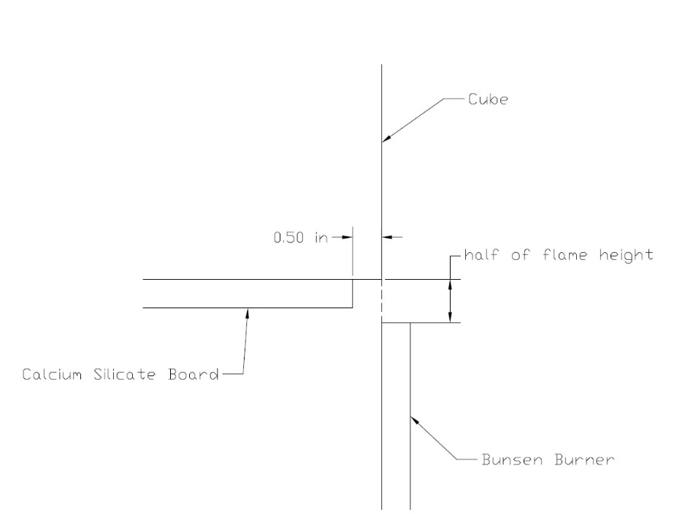
Figure 1 – Single cube small flame test set up diagram.
No Super-Critical condition was found through the initial tests at 1.5-inch flame applied for 12 seconds to all three systems. To find Super-Critical conditions for each system the test was increased in intensity systematically until a super critical condition was found. The increase was achieved by first exposing the cube to the flame for longer periods of time by adding 6 seconds to the exposure time. The second round of tests were 38 mm (1.5-inch) flames for 18 seconds. This turned out to be the Super-Critical condition for both the System 2 cubes (non-FR) and System 3 cubes (non-FR with cover). The System 1 cubes continued to be tested by increasing the time by increments of 6 seconds until the exposure time reached 30 seconds. After 30 seconds of flame exposure the part of the cube directly exposed to the flame or in the immediate area around the flame had burned or melted away and no longer reacted to the flame from the Bunsen Burner. A second increase in the flame intensity was then introduced by increasing the flame height. The following tests used a flame height that was 76 mm (3 inches) tall, twice the original flame height. The flame was then applied to the cube for 6 seconds, 12 seconds, 18, 24, and 30. This pattern was continued through increasing flame heights until a Super-Critical condition was found with a 152 mm (6-inch) flame applied to the cube for 12 seconds. The above results are presented in Figure 2 which show the trend towards Super-Critical conditions.

Figure 2 – Comparing the percentage of cubes that continued to burn after the Bunsen Burner was removed. When the bar indicated 100% that is the Super-Critical condition.

3.2.3 Smolder Testing

A smolder test was also used for each system. The test is modified from the ASTM E1353-08 standard.2 This test involves lighting a standard test cigarette, the NIST SRM1196 Standard Cigarette3, and placing it against the bottom edge of a cube which is placed on a calcium silicate board. A diagram of the cigarette test setup can be seen in Figure 3. The cigarette is then allowed to smolder until it goes out. The only difference from the standard is the cube and cigarette are placed on the calcium silicate board rather than on a second piece of the same material. The board is inert and keeps the results from the tests as the behavior of a single cube.
Each system was tested 6 times. There was no difference in burn or char pattern between the 3 systems. Each cube that was tested charred the length of the cigarette and 13 mm (0.5 inch) up from the bottom of the cube. An example of the smoldering results can be seen in Figure 4. There was no flame observed and all tests lasted 20-25 minutes.
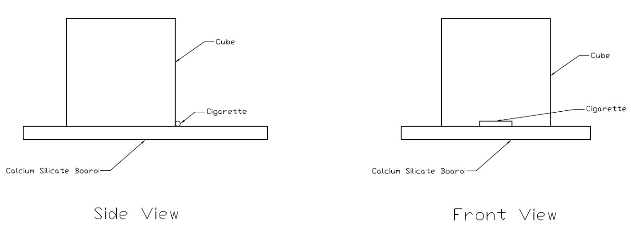
Figure 3 – Single cube smolder test set up.
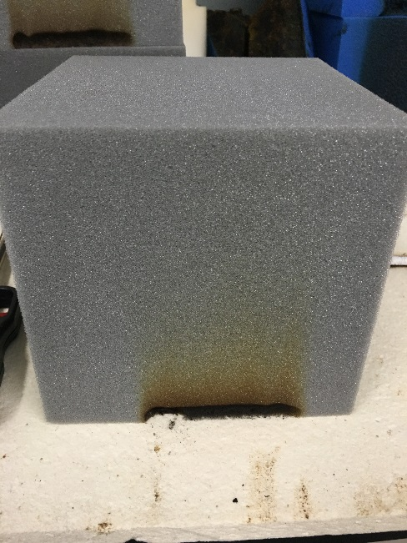
Figure 4 – Example of smolder test result of System 1. All smolder tests had the same results.

3.3 Intermediate Scale
To get an idea of how the cubes burn when piled up together we created two intermediate scale tests. One was a corner set up which tested 20 cubes and the second was a pit which tested 70 cubes. The ignition sources from the single cube tests were used in the large-scale tests. Each of the Super-Critical conditions for the three systems were used with the Bunsen Burner. We kept the single cube and intermediate scale tests as similar as possible by using the same burner gas, methane, Bunsen burner, and exposure time. We also did smolder tests with the large-scale set ups to see if having piles of cubes and different orientations of cubes yielded different results than from the single cube smolder tests.

3.3.1 Corner Tests
We constructed a corner out of Type-X gypsum board to create a space to pile 20 cubes and observe the burning patterns of the three systems. The corner was 0.92 m (3 feet) in each dimension. Then we used chicken wire to create a 0.46 m x 0.46 m (1.5 ft x 1.5 ft) space in the corner to hold the cubes up in the corner as a column rather than let the cubes roll down and create a pyramid like shape. The chicken wire helped keep the cubes in a configuration more consistent with what would exist in a larger pile of cubes without influencing the burning of the cubes. In gymnastic pits the cubes are not uniformly oriented. A diagram of the corner set up is shown in Figure 5. To reproduce the randomness of the pit cubes we tossed the cubes into the corner from 0.3 m to 0.92 m (one to three ft) away.
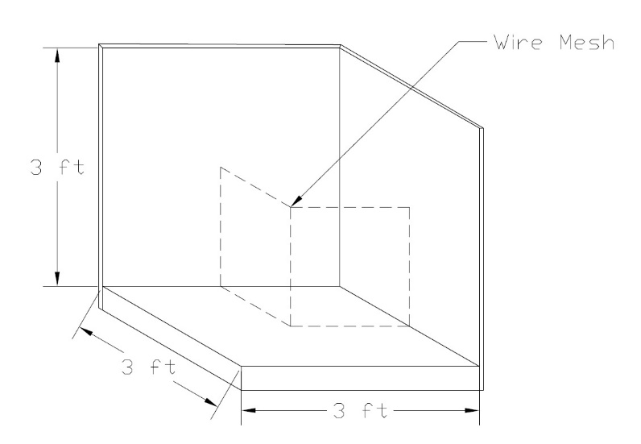
Figure 5 – Large-scale corner test set up

3.3.1.1 Small flame ignition tests
We performed two small flame tests with each system. We wanted to compare different ignition locations, one at the top and one at the bottom. Each system was ignited using its respective Super-Critical condition. The Bunsen Burner was attached to the end of the metal rod to ignite the cubes safely. They were ignited in the same manner as the single cube tests with the burner being held half of the height of the flame below the bottom of a cube. When one cube in each pile was ignited, the fire spread to the rest of the cubes in the pile. This makes each test Super-Critical. Once the pile of cubes was ignited they were allowed to burn until the test reached flame out which is when the fire goes out on its own. See Appendix A for additional results.
For System 1 both tests started out with the 76 mm (6 inch) flame at 30 seconds of exposure. Bottom and top ignitions developed very slowly. After the first 60 seconds the initial cube is still the only one burning for the top ignition test while the bottom ignition test had 2 cubes burning at that point. 150 seconds into the tests the top ignition test only spread to a few surrounding cubes. The fire quickly developed and then decayed from 3.5 to 6 minutes for both tests but a few smaller flames remained for another 4.5 minutes for the bottom ignition test and 5 minutes for the top ignition test making the time to flame out 10m:34s for the bottom ignition and 11m:21s for the top ignition.
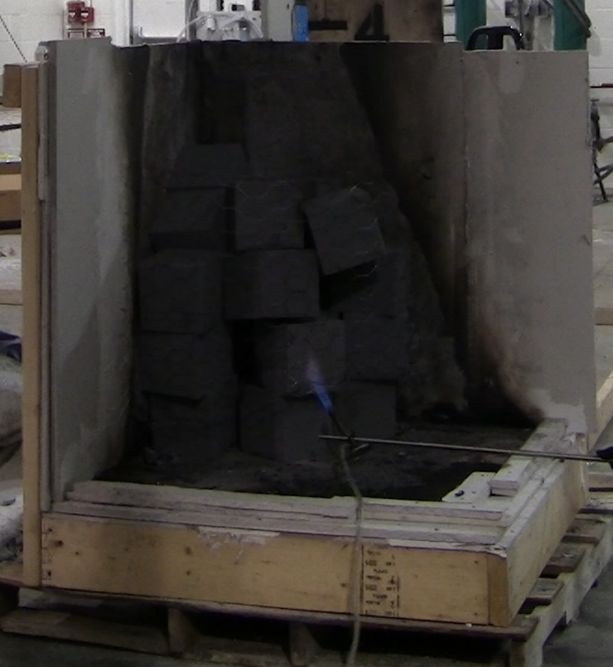
Figure 6 – System 1 corner bottom ignition test ignition location.
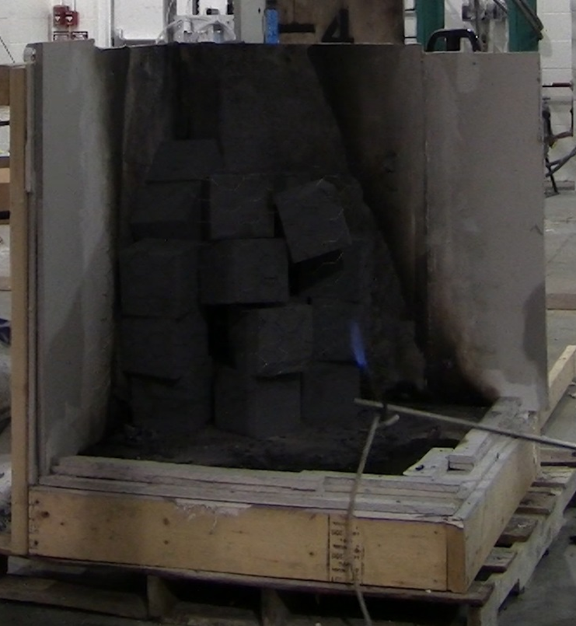
Figure 7 - System 1 corner top ignition test ignition location.
For System 2 both tests used a 38 mm (1.5 inch) flame that was applied for 18 seconds. The bottom ignition test spread much faster than the top ignition. After 60 seconds the bottom ignition pile has spread to most of the cubes while the top ignition pile is still only burning on the cube that was exposed to the Bunsen Burner. At 150 seconds the bottom ignition pile has melted down into a pool fire while the top ignition pile is still not entirely involved. The bottom ignition pile then dies out and only has a few small flames from 5 minutes to 8.5 minutes. During this time the top ignition reaches full involvement of the 20 cubes and then dies out. The bottom ignition test reached flame out after 6m:30s while top ignition lasted 9m:0s minutes. Both tests had nothing remaining after flame out.
Figure 8 - System 2 corner bottom ignition test ignition location.
Figure 9 - System 2 corner top ignition test ignition location.
For System 3 both tests used the same super critical condition as System 2. Both tests progressed at the same rate. After a minute the spread of both tests was slow and only had ignited a few cubes. After 150 seconds, most of the cubes have started to burn for both tests and have very similar flame heights. This remains the same throughout the remainder of the tests with the bottom and top ignition having very similar burn patterns. Both tests lasted just over 10.5 minutes leaving only a small amount of residue from the covers.
Figure 10 - System 3 corner bottom ignition test ignition location.
Figure 11 - System 3 corner top ignition test ignition location.
Using the same HRR equation used to find the HRR of the Bunsen Burner we estimated the HRR throughout each corner test. The video record of each test allowed flame heights to be measured. For each corner test, hydraulic diameter was estimated based on the cube pile footprint or taken as zero. As the fire developed for each test the flame height and hydraulic diameter varies throughout. The known diameters used for the corner test and pit test were 0.46m and 0.91m respectively. These diameters were used to estimate actual hydraulic diameter throughout each test. This range of hydraulic diameters did not significantly affect the HRRs estimated. The time histories of the flame heights then allowed HRR histories to be estimated using the following equation:
$$HRR={\left[\frac{(H+1.02*D)}{0.23}\right]}^{2.5}$$
H = Flame Height (m)
HRR = Heat Release Rate (kW)
D = Hydraulic Diameter (m)

Figure 12 shows a comparison of the corner test HRR histories. The recording of the System 1 top ignition test was lost so no HRR data is available for that test. System 2 bottom ignition started increasing the soonest but had the lowest peak HRR and reached its peak at almost the same time as System 1 bottom ignition did. Both System 3 tests had roughly the same HRR trends most likely due to the way the cover initially impedes the fire spread to cubes above for the bottom test but also drips down onto the lower cubes for the top test. The top ignition test for System 2 also had very similar HRR trends as the System 3 tests. The System 1 bottom test reached the highest HRR and died out the quickest once it reached its peak. System 1 has the shortest duration of a high HRR. System 2 bottom burns for the shortest amount of time. See Appendix C for additional HRR data.

Figure 12 - HRR comparison of the five Corner Tests. Reference hydraulic diameter, D=0.46m

3.3.1.2 Smolder tests
Each system was tested twice with a cigarette using the corner set up to see if the pile of cubes in the corner had a different result than the single cube tests. The cigarette was placed in a corner where 2 cubes met in a possible spot that the cigarette could have land if tossed into the pile. One test was done where the cigarette was placed near the bottom of the pile and the second test had the cigarette placed near the top. None of the cigarettes caused any of the cubes to ignite resulting in the same limited amount of smolder as in the single cube tests as can be seen in Figure 13.

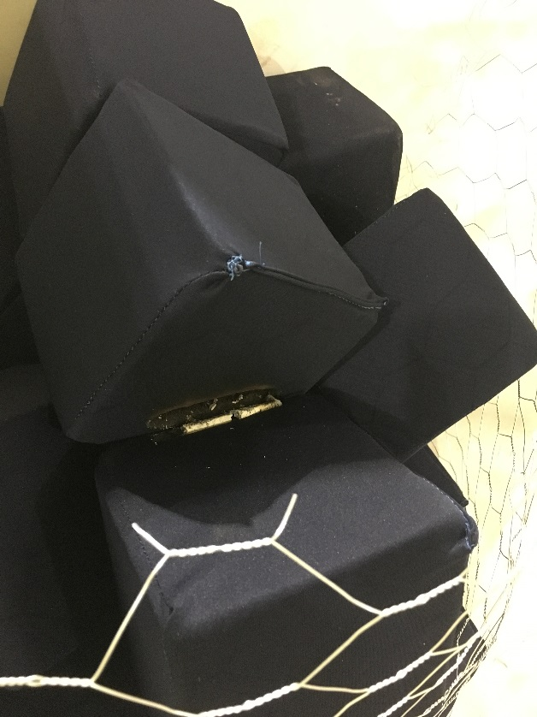
Figure 13 – Example of smolder test result for System 3 in the corner.

3.3.2 Pit Tests
We constructed a pit in the same fashion as the corner. The pit is a 0.92 m by 0.92 m by 0.92 m (3 foot by 3 foot by 3 foot) tall box of gypsum board with an open top, see Figure 13. This pit is a small-scale representation of a full gymnastics pit to better gauge the burn pattern of a larger number of cubes. One small flame test and one smolder test was done with each system. Each test used 70 cubes to fill the pit to the top. Only one of each test was performed due to limited supply of cubes.

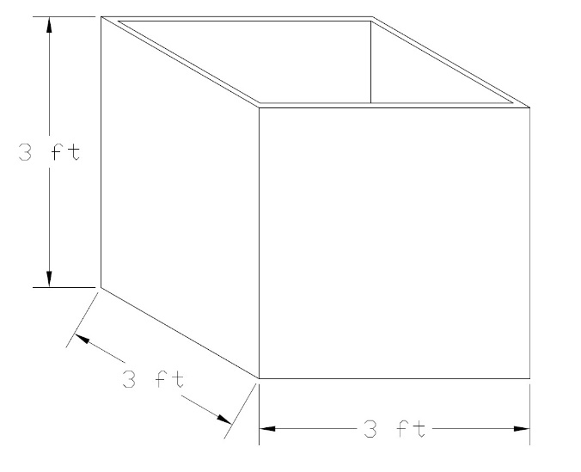
Figure 14 – Diagram of the pit set up

3.3.2.1 Small flame ignition tests
Each test used the same ignition source of the Bunsen Burner with the respective Super-Critical conditions found in the single cube tests. The Bunsen Burner was again attached to a pole to ignite the piles safely. One cube at the top of the pile was ignited in the same manner as the single cube and corner tests. Each test was Super-Critical and was allowed to reach flame out. See Appendix A for additional information about the testing.
For System 1 the flame spreads very slowly for the first 5m:30s and only ignites 3 of the cubes around it. Once one of the cubes below the top layer starts to burn, the fire spreads much more rapidly across the top half of the pit. By 7m:30s the pit is fully involved and continues to burn with an 2.4-36 m (8-12 foot) flame height until 10 minutes into the test. At 10 minutes the fire dies down significantly then continues to burn in the bottom of the pit until flame out at 14m:15s.

Figure 15 - System 1 pit test ignition location.
For System 2, in the first 60 seconds of the test there is very little fire spreading. The second 60 seconds has exponentially greater fire growth until the fire peaks at 3 minutes and continues to burn at this max burning rate until 5m:20s when it quickly dies down. Then there are only a few small flames that linger in the bottom until flame out at 10m:14s. The test results in 100% of the fuel being consumed.

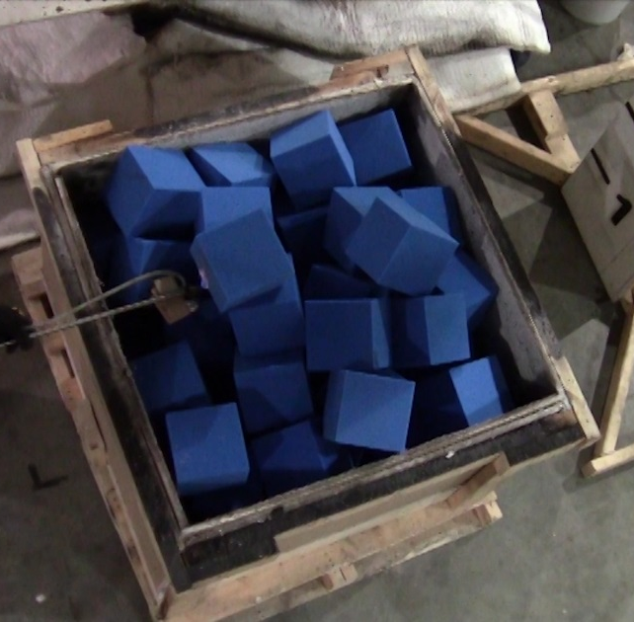
Figure 16 – System 2 pit test ignition location.
For System 3 after the burner was removed the fire spread very slowly at first. Then it quickly escalated to a very large fire, 3.0-3.6 m (10-12 foot) tall, that burned very rapidly. It died down after 5m:30s and then continued to burn the rest of the fuel for another 5 minutes. Effectively 100% of the fuel is consumed during the test. The only remains are likely the Velcro that was on half of the covers which did not completely burn. However, the percentage of remaining mass to the initial fuel load mass is below 1% and can be ignored.

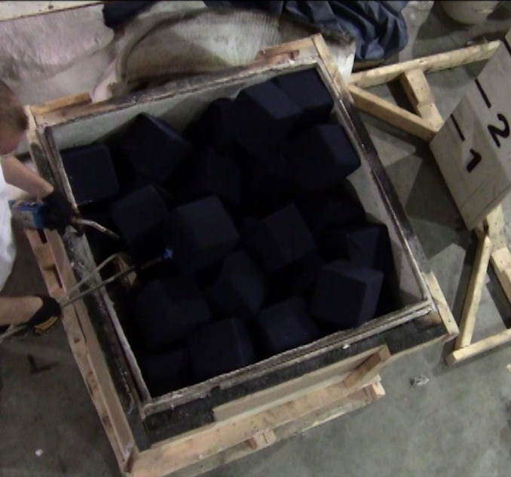
Figure 17 – System 3 pit test ignition location.
Using the same HRR equation used for the corner tests we estimated the HRR throughout each pit test. The video record of each test allowed flame heights to be measured. For each pit test the hydraulic diameter was estimated based on the pit characteristic length 0.92 m or taken as zero. This range of hydraulic diameters provides a potential range of HRRs based on the characteristics of the pit cubes as they burn in the open top pit. The time histories of the flame heights then allowed HRR histories to be estimated using the following equation:
$$HRR={\left[\frac{(H+1.02*D)}{0.23}\right]}^{2.5}$$

H = Flame Height (m)
HRR = Heat Release Rate (kW)
D = Hydraulic Diameter (m)

The resultant HRR histories are shown on Figure 17, Figure 18 and Figure 19 for each of the three systems. Figure 20 compares the HRR of each system when hydraulic diameter is taken as 0.92 m See Appendix C for additional HRR information and graphs.
From this we can see the FR’s in System 1 cause the HRR to grow much slower than in the other two systems. Systems 2 and 3 quickly jump up to 1500 kW and stay around that power output before quickly dying out. Once System 1 peaks at 1200 kW it then dies down at roughly the same rate as it grew. The cover on System 3 appears to cause the cubes to take slightly longer to start growing but only by 30-50 seconds. Then the cover causes a higher peak HRR than in System 2. The uncovered cubes in System 2 burn the quickest, followed closely by System 3. System 1 starts to grow as the other two are almost done burning.

Figure 18 – System 1 Comparison of HRR Equations

Figure 19 – System 2 Comparison of HRR Equations

Figure 20 – System 3 Comparison of HRR Equations

Figure 21 – HRR comparison of the three Pit Tests using HRR equation with diameter

4 Conclusions

4.1 Single Cube
From the single cube tests, we found at what point the different cubes will continue to burn after being exposed to a small methane flame. For System 1 no continued burning occurs from the applied flame from 12 to 30 seconds with a 38 mm (1.5 inch) flame height. Additional flame heights of 76 mm, 114 mm and 152 mm (3 inch, 4.5 inch, and 6 inch) flame heights were tested. When the 152 mm (6 inch) flame was applied for 12 seconds a Super-Critical condition was reached. System 2 and 3 are at a Super-Critical point at 18 seconds of flame exposure with the flame at 38 mm (1.5 inches) tall. The System 1 cubes are the most fire resistant of all of the cubes at the individual cube scale. Systems 2 and 3 have the same super-critical condition which is significantly less than System 1. However, the cover on System 3 causes the initial flame spread to be slowed as the cover needs to burn off first but it does not cause the cube to need a higher super-critical condition. The cigarette tests showed the same results for every test. There was no ignition of the cubes and minimal smoldering.

4.2 Intermediate scale
Corner Tests
The System 1 tests developed very slowly but once the flames started spreading the rest of the cubes burned very quickly. The bottom ignition spread faster than the top ignition test because the flames were able to spread up to the cubes above. The top ignition test had to wait for the cube that was initially on fire to burn down more to the point where it would drip and fall onto the cube below to ignite them. This is also true for System 2. However, System 2 spread much faster for each test than System 1 did initially. System 3 spread slightly slower and took longer to reach its peak than System 1. Unlike Systems 1 and 2, top and bottom ignition for System 3 spread at the same rate. The cover impeded the bottom ignition test from spreading up as fast as System 2 bottom ignition but allowed the System 3 top ignition test to spread as fast as the System 3 bottom ignition test. Once both tests for each system reached full involvement they quickly burned down and used up most of the fuel. For System 1 the time from the peak to decay was about 1m:45s for both tests. For System 2 it was 2m:30s, and for System 3 it was 3m:15s.
The cover in System 3 has a similar effect as the FR has in delaying the fire growth but the initial flame exposure to System 3 is less intense than in System 1. The cover also does not change the Super-Critical condition of the non-FR cube. However, for the top ignition tests System 2 and 3 were very similar showing no benefit in having a cover.

Pit Tests
System 1 took 5m:30s for the fire to spread across the entire opening at the top of the pit. System 2 took 3 minutes to reach the same point and System 3 only took 2m:30s. At 5m:30s for Systems 2 and 3 the fire began to decay and burn down at the bottom of the pit rather than at the top. System 1 did not start to decay until 10 minutes into the test. After most of the flames died out the remaining flames burned for roughly 5 additional minutes until they burned out on their own. All three systems used up 100% of the fuel load. The only difference between Systems 2 and 3 is a slight delay in the rapid fire growth of System 3. Both Systems 2 and 3 develop much faster and reach a higher HRR than System 1. The main factor is the time it takes the initial cube that is ignited to burn down enough to spread to the cubes around and under it. Once that happens the burning is relatively similar between the three systems.

4.3 Overall Summary and Suggestions

All three systems are relatively safe to begin with as it requires at least 23 watts of energy to cause any of them to continue to burn after exposure. Lit cigarettes are not enough to cause any of the systems to ignite. The cover on System 3 slightly delays the initial fire growth but not significantly. The cover also causes the HRR to be greater than System 2 without the covers. The cover is not a useful addition to the non-FR cubes. System 1 is better than the other two as it takes around 400 watts of energy to cause the System 1 cubes to continue to burn in comparison to the others. System 1 is significantly more fire resistant but the non-FR cube in Systems 2 and 3 is fire resistant enough to stand up to likely ignition sources like a lit cigarette.

End Notes
1 - Carignan, C. C., Fang, M., Stapleton, H. M., Heiger-Bernays, W., McClean, M. D., & Webster, T. F. (2016). Urinary biomarkers of flame retardant exposure among collegiate U.S. gymnasts. Environment International, 94, 362-368. doi:10.1016/j.envint.2016.06.030
2 - Courtney C. Carignan, Wendy Heiger-Bernays, Michael D. McClean, Simon C. Roberts, Heather M. Stapleton, Andreas Sjödin, and Thomas F. Webster. (2013). Flame retardant exposure among collegiate united states gymnasts. (). doi:10.1021/es4037868
3 - TECHNICAL BULLETIN 117, State of California department of consumer affairs bureau of home furnishings and thermal insulation 3485 orange grove avenue north highlands, ca 95660-5595
4 - Standard test methods for cigarette ignition resistance of components of upholstered furniture doi:10.1520/E1353-08A
5 - SRM 1196 - standard cigarette for ignition resistance testing &nbsp; Retrieved from https://www-s.nist.gov/srmors/view_detail.cfm?srm=1196
6 - Drysdale, D. (1985). An introduction to fire dynamics. Chichester u.a: Wiley.

Appendix A – Testing Data

System 1 at 12 Seconds of Flame Expousre
11 of the 12 tests did not continue to burn after the burner flame was removed. The one test that did continue to burn can be considered anomalous because the test surface that the cube was on had residue from previous tests and caused the cube being tested to continue to burn. The average mass loss was 0.28 grams for the tests that did not continue to burn. Compared to the average initial mass of all of the gray cubes of 76.3 grams, there is hardly any loss of mass. Figure 8 shows test 5 burning freely while the other tests have gone out or nearly gone out. Note in the table below test number 5 is the anomalous test.

Cube System | Test Number | Initial Mass (g) | Final Mass (g) | Time (s) | Mass Loss (g) | Mass Loss Rate (g/s)
System 1 | 1 | 73.52 | 73.34 | 12 | 0.18 | 0.01
 | 2 | 77.22 | 76.96 | 12 | 0.26 | 0.02
 | 3 | 80.97 | 80.71 | 12 | 0.26 | 0.02
 | 4 | 76.19 | 75.88 | 12 | 0.31 | 0.03
 | 5 | 76.53 | 61.39 | 150 | 15.14 | 0.10
 | 6 | 74.14 | 73.8 | 12 | 0.34 | 0.03
 | 7 | 75.14 | 74.72 | 12 | 0.42 | 0.04
 | 8 | 80.5 | 80.12 | 12 | 0.38 | 0.03
 | 9 | 74.43 | 74.11 | 12 | 0.32 | 0.03
 | 10 | 79.74 | 79.66 | 12 | 0.08 | 0.01
 | 11 | 73.92 | 73.64 | 12 | 0.28 | 0.02
 | 12 | 73.41 | 73.12 | 12 | 0.29 | 0.02
Table 1A - System 1 at 12 Seconds Data

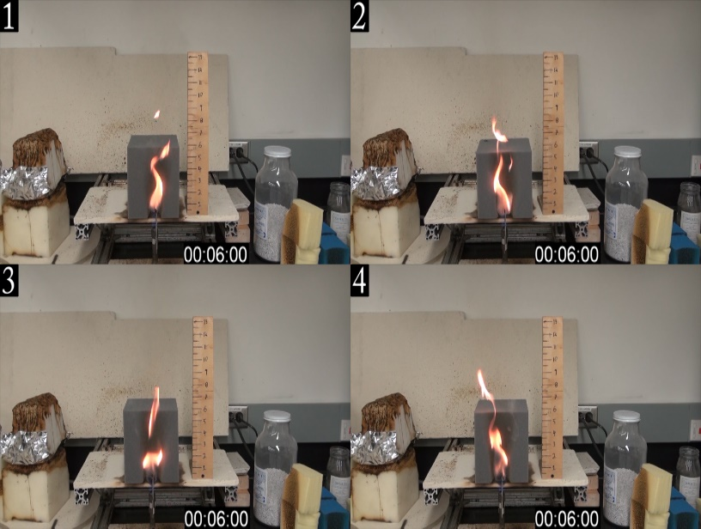
Figure 1A - Tests 1 to 4 at 6 seconds into the flame being applied. All cubes have a similar burn pattern with flames only a few inches above the top of the cubes.
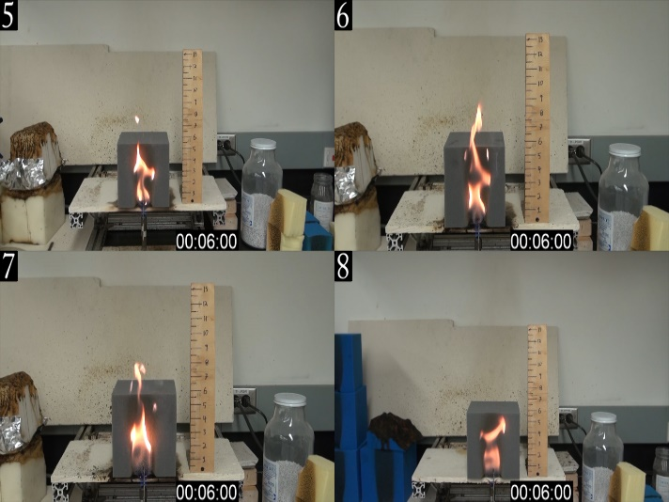
Figure 2A - Tests 5 to 8 at 6 seconds into the flame being applied. All cubes have a similar burn pattern with flames only a few inches above the top of the cubes.

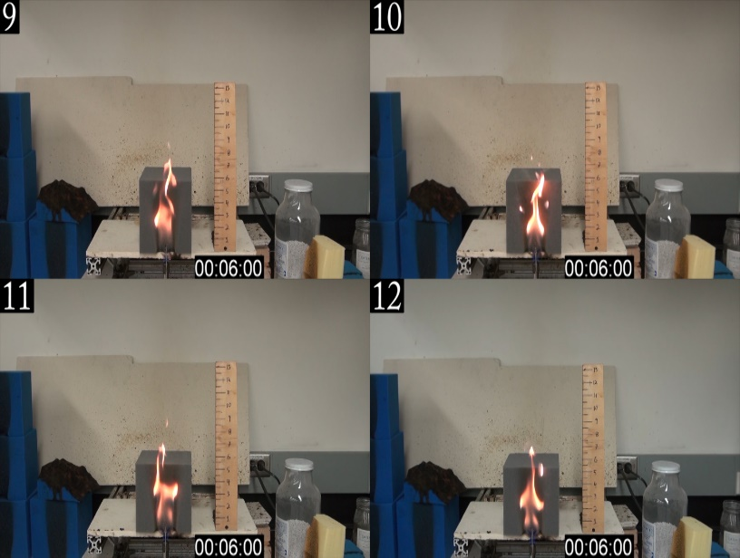
Figure 3A - Tests 9 to 12 at 6 seconds into the flame being applied. All cubes have a similar burn pattern with flames only a few inches above the top of the cubes.
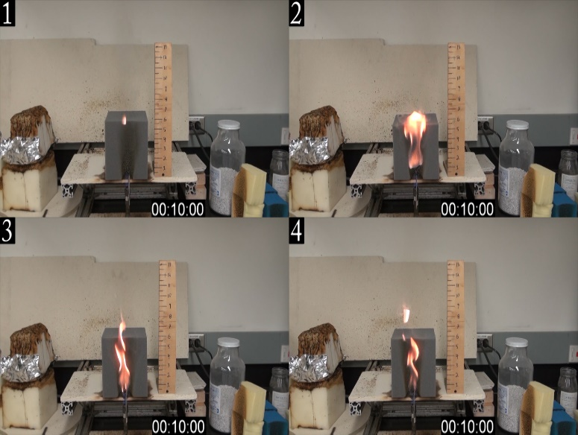
Figure 4A - Tests 1 to 4 at 10 seconds into the test. The burn patterns and flame heights have not changed much from 6 seconds.

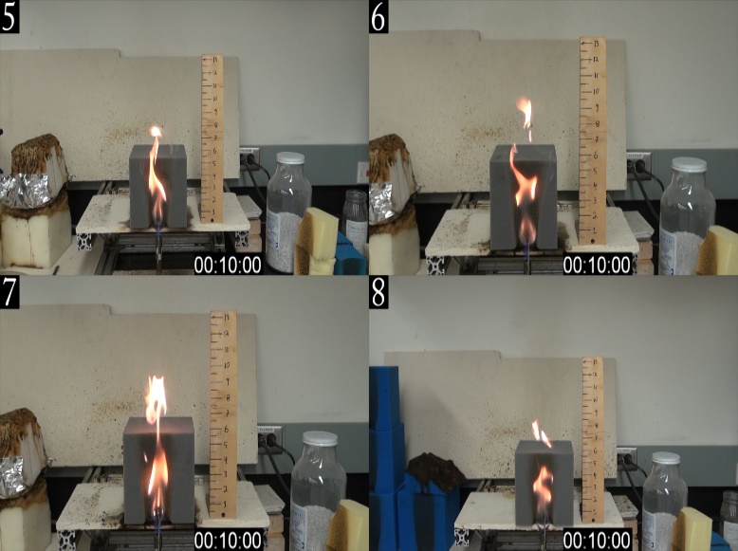
Figure 5A - Tests 5 to 8 at 10 seconds into the test. The burn patterns and flame heights have not changed much from 6 seconds.
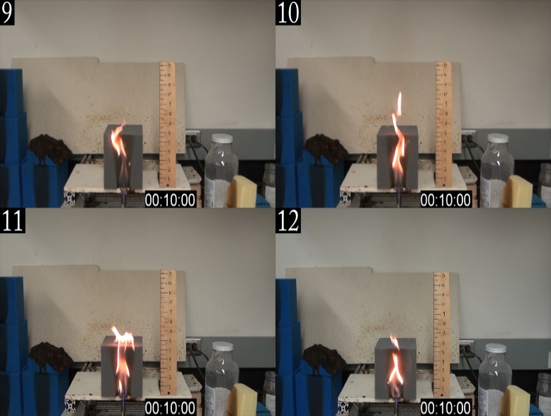
Figure 6A - Tests 9 to 12 at 10 seconds into the test. The burn patterns and flame heights have not changed much from 6 seconds.

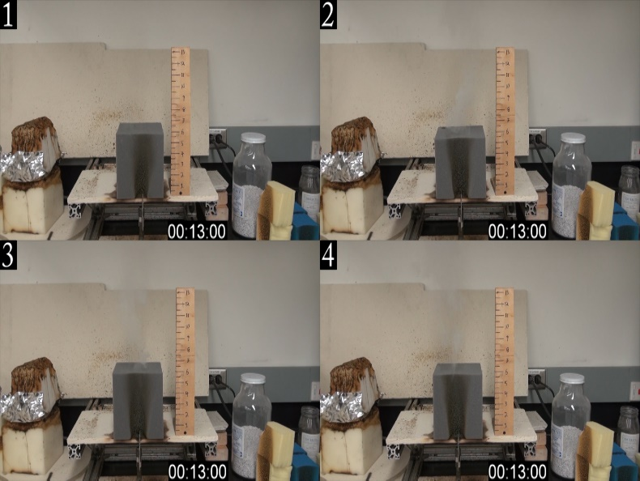
Figure 7A - Tests 1 to 4 at 13 seconds. All tests have stopped or are about to stop burning.
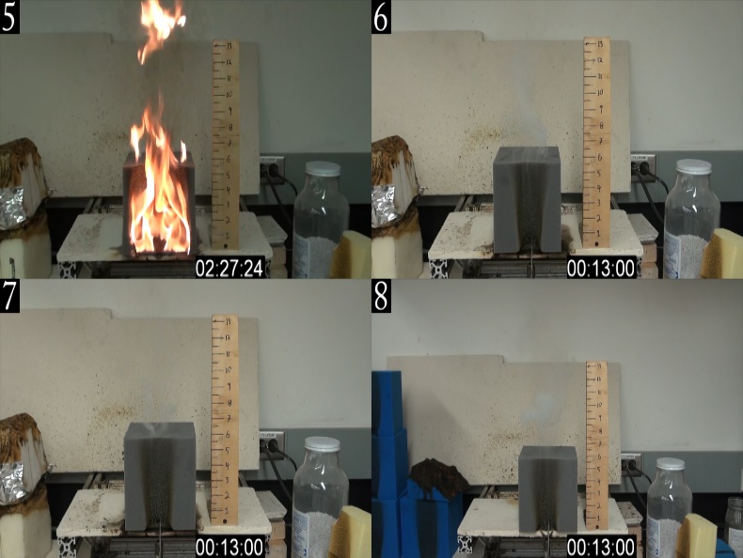
Figure 8A - Test 5 at 2:27 and all others at 13 seconds. All but test 5 has stopped or is about to stop burning.

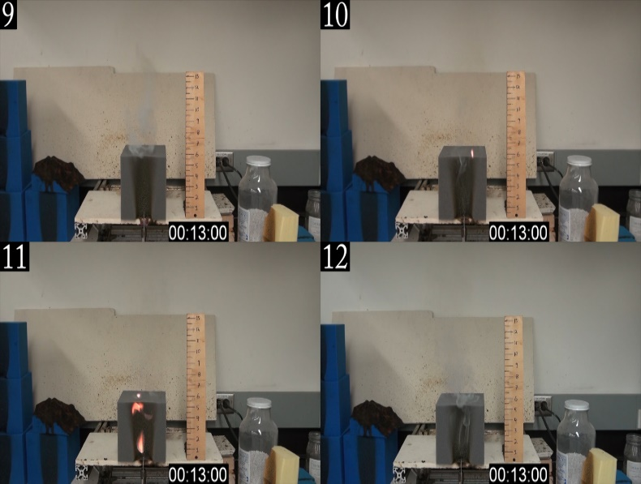
Figure 9A - Tests 9 to 12 at 13 seconds. All tests have stopped or are about to stop burning.

System 2 at 12 Seconds of Flame Exposure
Cube System | Test Number | Initial Mass (g) | Final Mass (g) | Time (s) | Mass Loss (g) | Mass Loss Rate (g/s)
System 2 | 1 | 103.53 | 103.11 | 12 | 0.42 | 0.04
 | 2 | 105.62 | 105.14 | 14 | 0.48 | 0.03
 | 3 | 104.43 | 103.93 | 15 | 0.5 | 0.03
 | 4 | 104.47 | 49.04 | 150 | 55.43 | 0.37
 | 5 | 103.7 | 57.15 | 150 | 46.55 | 0.31
 | 6 | 105.27 | 104.88 | 16 | 0.39 | 0.02
 | 7 | 106.4 | 71.73 | 150 | 34.67 | 0.23
 | 8 | 103.91 | 103.58 | 12 | 0.33 | 0.03
 | 9 | 104.55 | 104.15 | 12 | 0.4 | 0.03
 | 10 | 103.77 | 70.21 | 150 | 33.56 | 0.22
 | 11 | 104.51 | 67.8 | 150 | 36.71 | 0.24
 | 12 | 104.69 | 104.41 | 12 | 0.28 | 0.02
7 of the 12 tests did not ignite. There was no noticeable difference between the tests with ignition versus without ignition. Of the ones that continued to burn, the average mass loss was 41.4 grams. The average mass loss of the cubes that did not continue to burn was minimal at 0.4 grams. The reason a cube continues to burn or not appears to be whether or not the flame can cause the top edge of the cube to burn. If this happens then the cube always continues to burn. The inconsistency of the cubes burning is likely a combination of how dynamic and unpredictable fire is and only sometimes burns up the face of the cube enough to get the top edge to burn with the 12 seconds of applied flame. In figures 13-15 the tests that continued to burn have the top of the cube engulfed in flame. Test 4 in figure 13 and test 5 in figure 14 had flame spread down the face sooner than tests 7, 10, and 11 in figures 14 and 15. When the flame spread down the face faster the mass loss was about 40-50% higher than the 3 tests that had slower flame spread. For the tests that did not continue to burn there was still some flame on the surface of the cubes for up to 4 seconds after the burner was removed.

Table 2A - System 2 at 12 Seconds Data

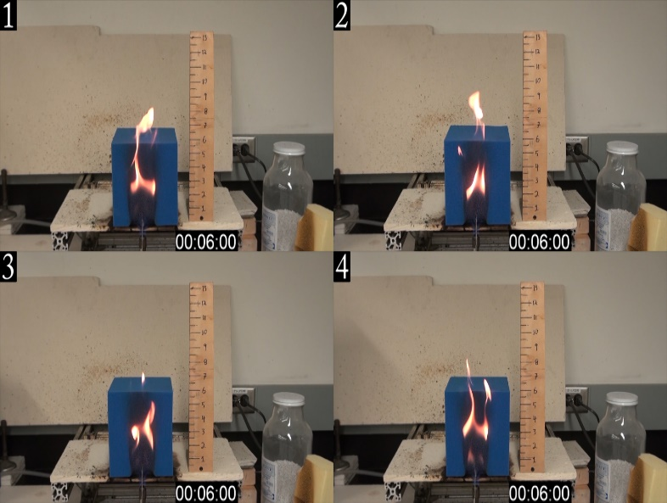
Figure 10A - Tests 1 to 4 at 6 seconds. All of these tests appear similar to the System 1 cubes at this point in the test with similar burn patterns and flame heights.
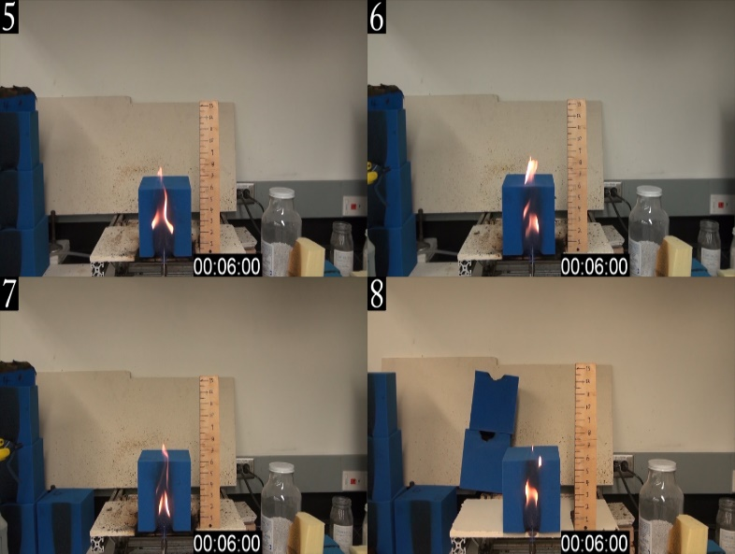
Figure 11A - Tests 5 to 8 at 6 seconds. All of these tests appear similar to the System 1 cubes at this point in the test with similar burn patterns and flame heights.

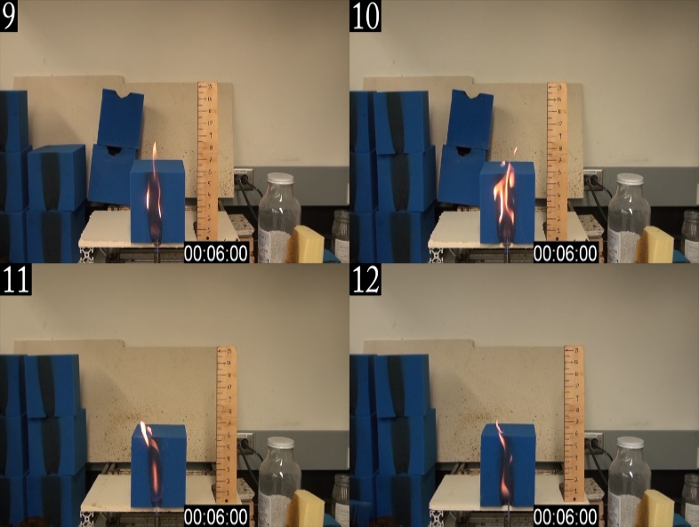
Figure 12A - Tests 9 to 12 at 6 seconds. All of these tests appear similar to the System 1 cubes at this point in the test with similar burn patterns and flame heights.
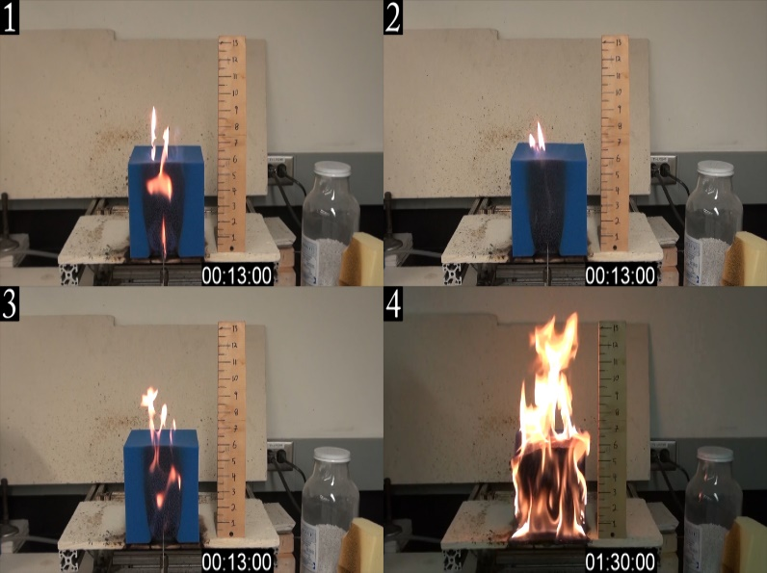
Figure 13A - Tests 1 to 4 that continued to burn are at 1m:30s. Those tests have greatly increased flame height and burn area. The remaining tests have the same small burn area and flame height as System 1 tests.

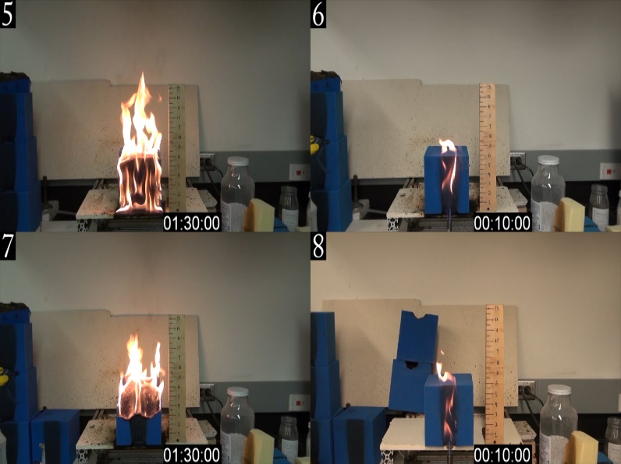
Figure 14A - Tests 5 to 8 that continued to burn are at 1m:30s. Those tests have greatly increased flame height and burn area. The remaining tests have the same small burn area and flame height as System 1 tests.
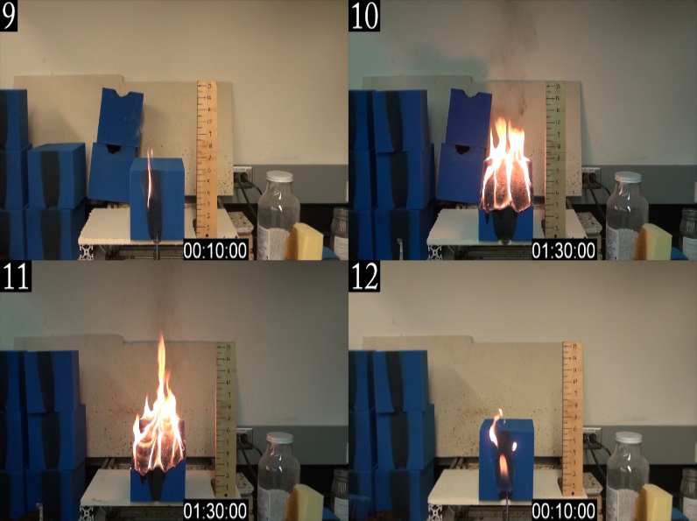
Figure 15A - Tests 9 to 12 that continued to burn are at 1:30. Those tests have greatly increased flame height and burn area. The remaining tests have the same small burn area and flame height as System 1 tests.

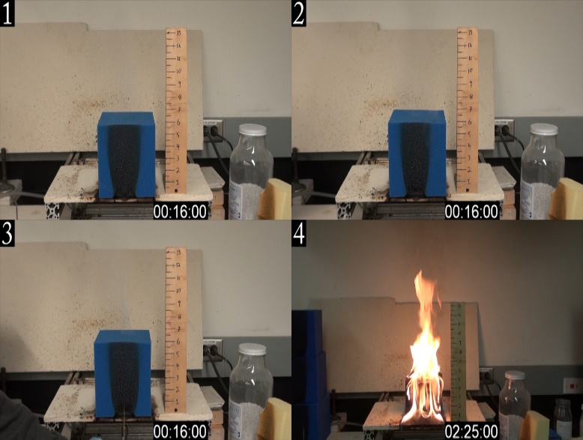
Figure 16A - Tests 1 to 4 that did not continue to burn are at 15 or 16 seconds and tests that did are at 2m:25s. All cubes that continued to burn have reached a similar shape and burn pattern. The tests that did not continue to burn have all gone out. Several did have some burning after the Bunsen burner was removed but not for more than 4 seconds.
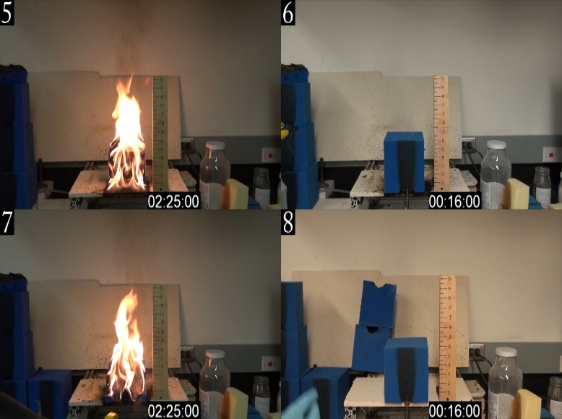
Figure 17A - Tests 5 to 8 that did not continue to burn are at 15 or 16 seconds and tests that did are at 2m:25s. All cubes that continued to burn have reached a similar shape and burn pattern. The tests that did not continue to burn have all gone out. Several did have some burning after the Bunsen burner was removed but not for more than 4 seconds.

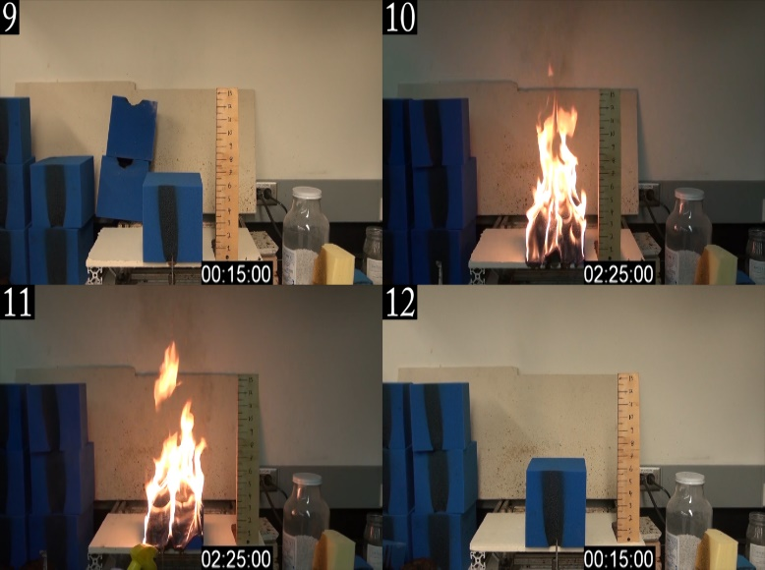
Figure 18A - Tests 9 to 12 that did not continue to burn are at 15 or 16 seconds and tests that did are at 2:25. All cubes that continued to burn have reached a similar shape and burn pattern. The tests that did not continue to burn have all gone out. Several did have some burning after the Bunsen burner was removed but not for more than 4 seconds.

System 3 at 12 Seconds of Flame Exposure
4 of the 6 tests continued to burn. The other 2 tests did not continue to burn. This is most likely because the flaming cover fell off of the cube. Of the ones that continued to burn the average mass loss was 36.9 grams which is slightly less than for System 2. Compared to the System 2 cubes the addition of the covers increases the likelihood of the cube to continue to burn. For tests 1 and 2 in figure 21 the cubes continued to burn on one side while tests 3 and 4 in figures 21 and 22 burned from the front face towards the back.

Cube System | Test Number | Initial Mass (g) | Final Mass (g) | Time (s) | Mass Loss (g) | Mass Loss Rate (g/s)
System 3 | 1 | 121.29 | 108.44 | 150 | 12.85 | 0.09
 | 2 | 115.55 | 85.43 | 150 | 30.12 | 0.20
 | 3 | 115.51 | 55.2 | 150 | 60.31 | 0.40
 | 4 | 124.85 | 80.56 | 150 | 44.29 | 0.30
 | 5 | 123.09 | 120.83 | 24 | 2.26 | 0.09
 | 6 | 122.86 | 122.08 | 20 | 0.78 | 0.04
Table 3A - System 3 at 12 Seconds Data

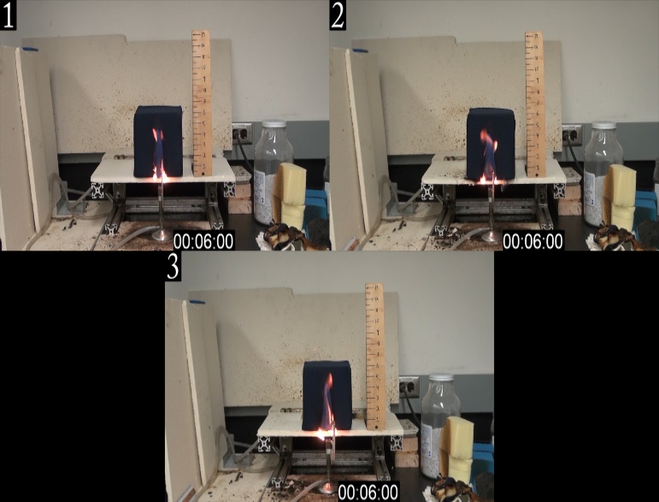
Figure 19A - Tests 1 to 3 at 6 seconds. The cover quickly burns up the middle exposing the blue cube.

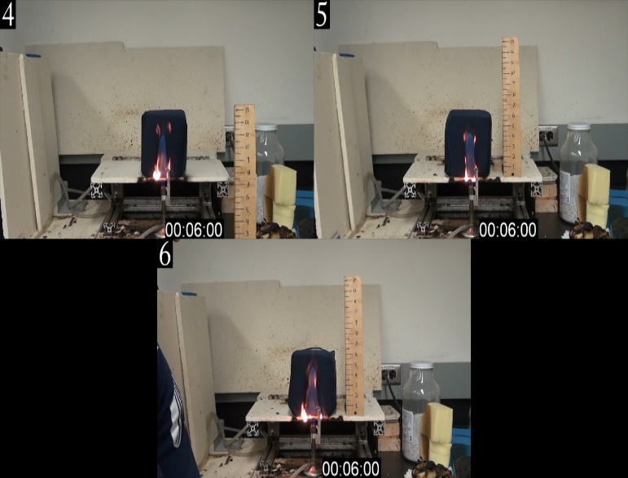
Figure 20A - Tests 4 to 6 at 6 seconds. The cover quickly burns up the middle exposing the blue cube.
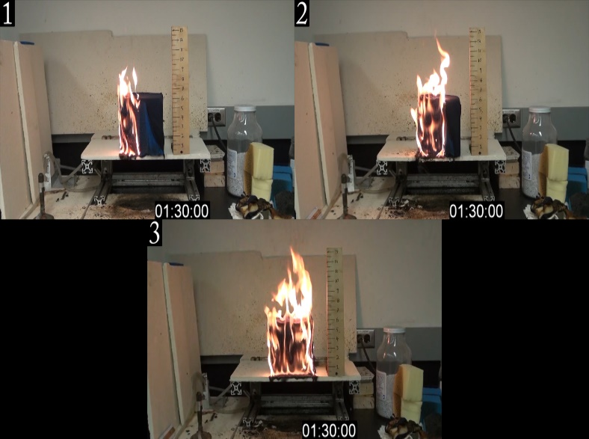
Figure 21A - Tests 1 to 3 at 1m:30s. The fabric continued to burn on only the left side and the spread while both sides of the fabric continued to burn for test 3. Unlike the other cubes that burned, the covers cause the cube to burn on the entire face rather than start at the top.

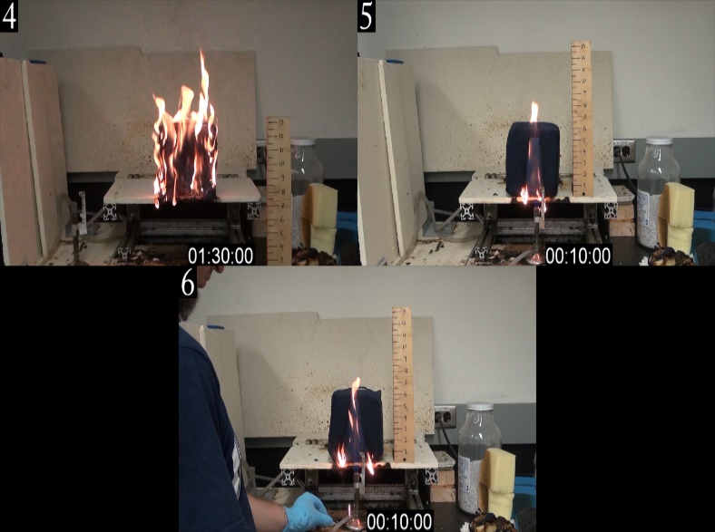
Figure 22A - Tests 4 at 1m:30s, and test 5 and 6 at 10 seconds. The fabric continued to burn on only the left side and the spread while both sides of the fabric continued to burn for test 4. Unlike the other cubes that burned, the covers cause the cube to burn on the entire face rather than start at the top.
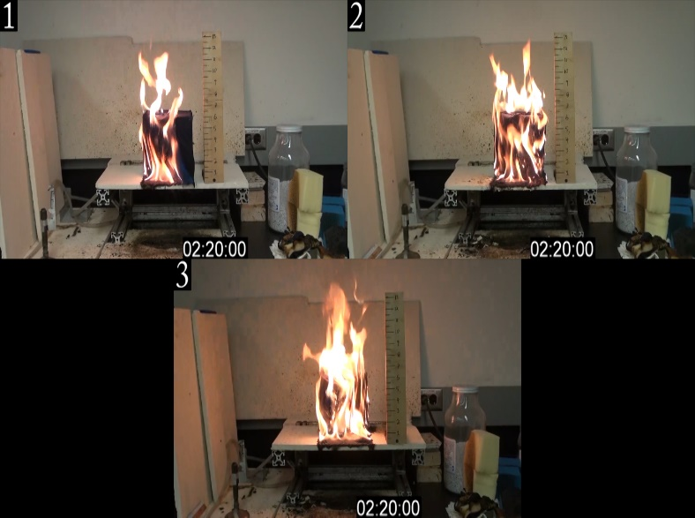
Figure 23A - Tests 1 to 3 at 2m:20s just after the last burning part of the cover fell off. Flames on tests 1 and 2 spread across the face more, and test 3 continued to burn straight back.

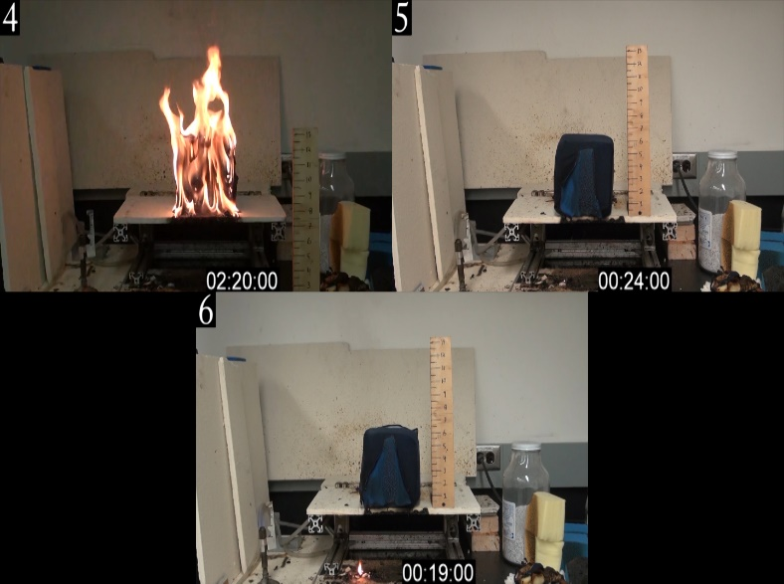
Figure 24A - Test 4 at 2m:20s, and tests 5 and 6 just after the last burning part of the cover fell off. Flames on test 4 continued to burn straight back.

System 1 at 18 Seconds of Flame Exposure
With a 50% increase in time that the Bunsen burner flame was applied to the cube, none of the cubes continued to burn. The mass loss increased due to the longer application of the burner but the mass loss rate did not change. All of the cubes stopped burning as soon as the Bunsen Burner flame is removed compared to the System 2 cubes that do not continue to burn but still have flame for a few seconds after the burner is removed.

Cube System | Test Number | Initial Mass (g) | Final Mass (g) | Time (s) | Mass Loss (g) | Mass Loss Rate (g/s)
System 1 | 1 | 86.67 | 86.13 | 18 | 0.54 | 0.03
 | 2 | 82.83 | 82.17 | 18 | 0.66 | 0.04
 | 3 | 83.36 | 82.95 | 18 | 0.41 | 0.02
 | 4 | 80.92 | 80.44 | 18 | 0.48 | 0.03
 | 5 | 73.96 | 73.39 | 18 | 0.57 | 0.03
 | 6 | 81.87 | 81.37 | 18 | 0.5 | 0.03
Table 4A - System 1 at 18 Seconds Data

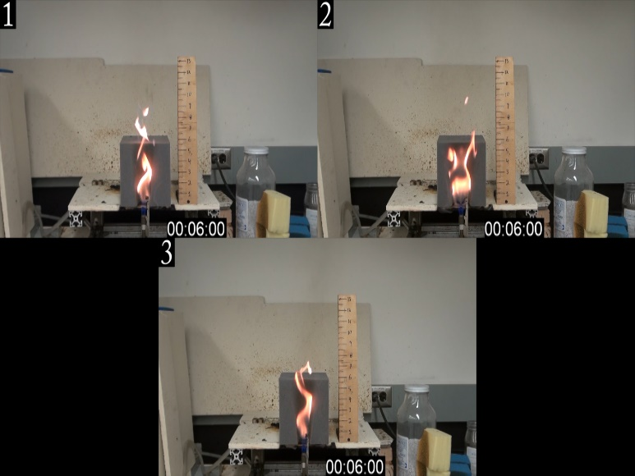
Figure 25A - Tests 1 to 3 at 6 seconds. Consistent burning compared to the 12 second tests.

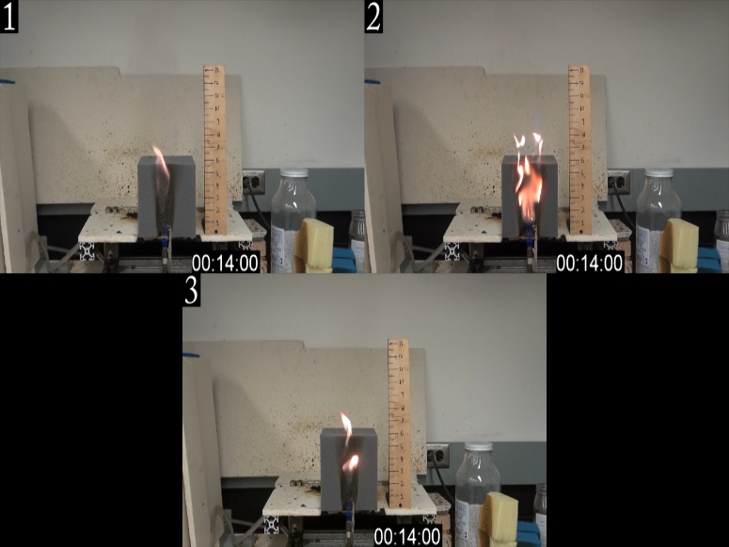
Figure 26A - Tests 1 to 3 at 14 seconds. The width of the burnt part of the cube is similar to that of the 12 second tests.
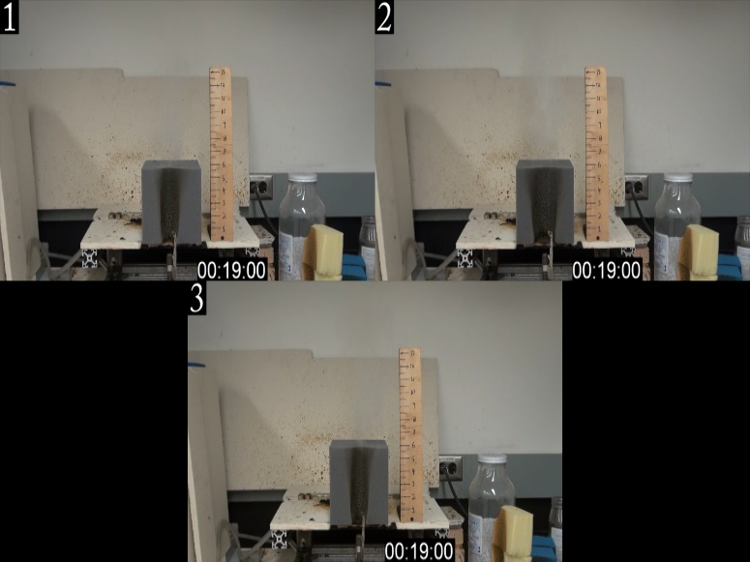
Figure 27A - Tests 1 to 3 at 19 seconds. All of the flames have gone out as soon as the burner is removed.

System 2 at 18 Seconds of Flame Exposure
All cubes continue to burn after the burner flame was removed. The first test has twice the mass loss as the second and third because it burned on the entire front face rather than the typical burn pattern of burning from the top down so the cube burned faster. Figure 29 shows the difference between the burn patterns. Compared to the 12 second tests these cubes consistently continue to burn after 18 seconds of flame. This indicates a super-critical condition for this system. If the burner was applied for any time longer than 18 seconds would result in the cube continuing to burn as well.

Cube System | Test Number | Initial Mass (g) | Final Mass (g) | Time (s) | Mass Loss (g) | Mass Loss Rate (g/s)
System 2 | 1 | 103.34 | 51.69 | 150 | 51.65 | 0.34
 | 2 | 104.14 | 78.89 | 150 | 25.25 | 0.17
 | 3 | 104.87 | 79.77 | 150 | 25.1 | 0.17
 | 4 | 103.62 | 56.73 | 150 | 46.89 | 0.31
 | 5 | 103.9 | 66.21 | 150 | 37.69 | 0.25
 | 6 | 103.41 | 73.29 | 150 | 30.12 | 0.20
Table 5A - System 2 at 18 Seconds Data

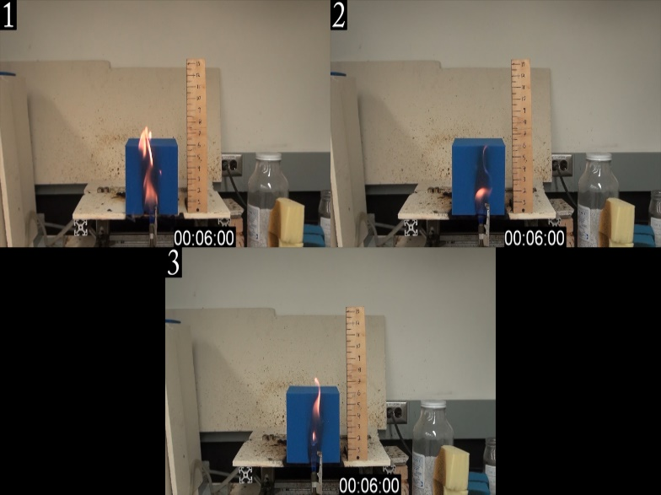
Figure 28A - Tests 1 to 3 at 6 seconds with similar burn patterns to the 12 second tests.

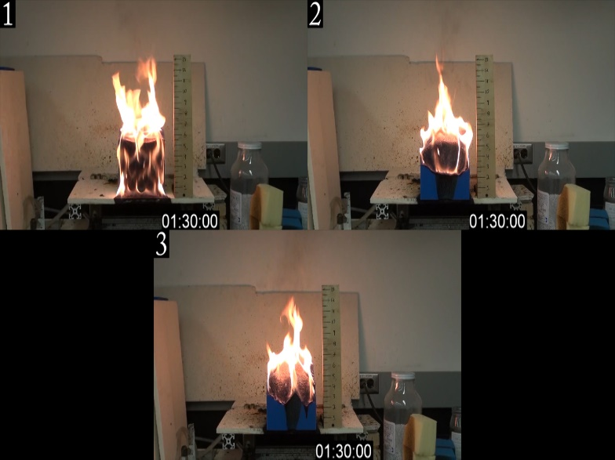
Figure 29A - Tests 1 to 3 at 1m:30s. Test 1 burned around the front rather than from the top down and had twice as much mass loss as tests 2 and 3 but overall consistent to tests that continued to burn after 12 seconds of applied flame.
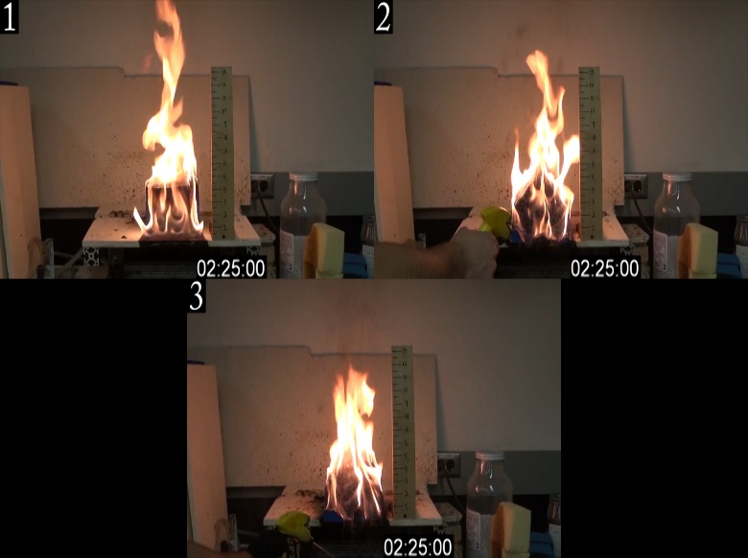
Figure 30A - Tests 1 to 3 at 2m:25s with similar flame height and the entire height of the cube is engulfed in flame.

System 3 at 18 Seconds of Flame Exposure
Every test continued to burn after the burner flame was removed. This system continued to burn in a similar manner as at 12 seconds. This is a super-critical condition for this system. The burn pattern continues to be unique compared to System 1 and 2 where it burns around the front rather than down from the top.

Cube System | Test Number | Initial Mass (g) | Final Mass (g) | Time (s) | Mass Loss (g) | Mass Loss Rate (g/s)
System 3 | 1 | 117.73 | 76.83 | 150 | 40.9 | 0.27
 | 2 | 118.06 | 55.5 | 150 | 62.56 | 0.42
 | 3 | 114.54 | 70.04 | 150 | 44.5 | 0.30
 | 4 | 107.3 | 60.65 | 150 | 46.65 | 0.31
 | 5 | 119.35 | 72.73 | 150 | 46.62 | 0.31
 | 6 | 119.58 | 66.71 | 150 | 52.87 | 0.35
Table 6A - System 3 at 18 Seconds Data

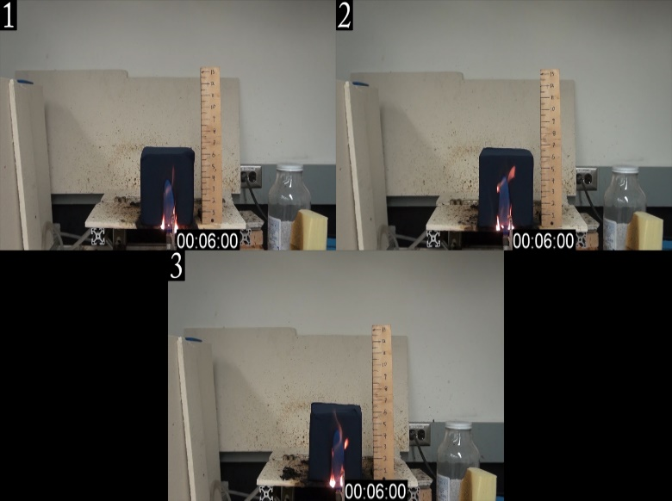
Figure 31A - Tests 1 to 3 at 6 seconds. Burn pattern is the same as the 12 second tests.

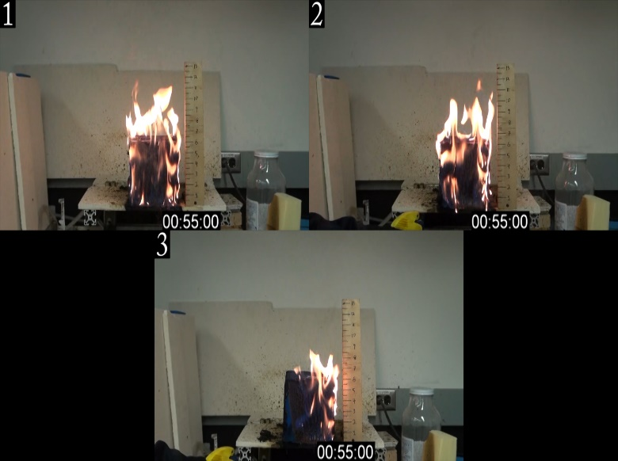
Figure 32A - Tests 1 to 3 at 55 seconds. Tests 1 and 2 burned on both sides while test 3 only continued to burn on the right side.
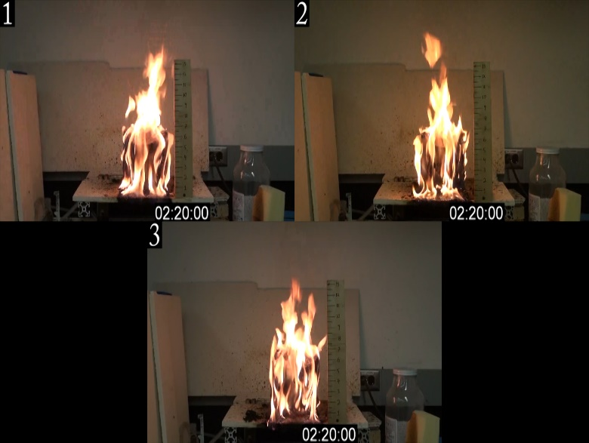
Figure 33A - Tests 1 to 3 at 2m:20s. All tests became covered in flames on all sides.

System 1 at 24 Seconds of Flame Exposure
Adding an additional 6 seconds to the tests had the same results as the previous tests where the cubes self-extinguished as soon as the burner was removed. The mass loss continued to be very minimal.

Cube System | Test Number | Initial Mass (g) | Final Mass (g) | Time (s) | Mass Loss (g) | Mass Loss Rate (g/s)
System 1 | 1 | 76.01 | 75.61 | 24 | 0.4 | 0.02
 | 2 | 82.3 | 82.14 | 24 | 0.16 | 0.01
 | 3 | 80.18 | 79.74 | 24 | 0.44 | 0.02
 | 4 | 73.19 | 72.92 | 24 | 0.27 | 0.01
 | 5 | 74.96 | 74.3 | 24 | 0.66 | 0.03
 | 6 | 73.53 | 73.12 | 24 | 0.41 | 0.02
Table 7A - System 1 at 24 Seconds Data

System 1 at 30 Seconds of Flame Exposure
With a 150% increase in time from the original 12 seconds that the referenced standards use the cubes continue to behave as they were designed to and do not continue to burn. The mass loss continues to be very minimal.

Cube System | Test Number | Initial Mass (g) | Final Mass (g) | Time (s) | Mass Loss (g) | Mass Loss Rate (g/s)
System 1 | 1 | 83.11 | 82.55 | 30 | 0.56 | 0.02
 | 2 | 79.71 | 79.17 | 30 | 0.54 | 0.02
 | 3 | 74.19 | 73.71 | 30 | 0.48 | 0.02
 | 4 | 77 | 76.6 | 30 | 0.4 | 0.01
 | 5 | 86.36 | 85.92 | 30 | 0.44 | 0.01
 | 6 | 73.85 | 73.42 | 30 | 0.43 | 0.01
Table 8A - System 1 at 30 Seconds Data

System 2 at 6 Seconds of Flame Exposure
At 50% of the initial length of exposure none of the cubes continued to burn. This gives a subcritical condition for this system. There is a 12 second window when this system goes from subcritical to supercritical.

Cube System | Test Number | Initial Mass (g) | Final Mass (g) | Time (s) | Mass Loss (g) | Mass Loss Rate (g/s)
System 2 | 1 | 104.57 | 104.46 | 6 | 0.11 | 0.018
 | 2 | 104.86 | 104.74 | 6 | 0.12 | 0.020
 | 3 | 103.31 | 103.2 | 6 | 0.11 | 0.018
 | 4 | 103.58 | 103.46 | 6 | 0.12 | 0.020
 | 5 | 104.1 | 103.96 | 6 | 0.14 | 0.023
 | 6 | 103.71 | 103.6 | 6 | 0.11 | 0.018
Table 9A - System 2 at 6 Seconds Exposure

System 3 at 6 Seconds of Flame Exposure
At 50% of the initial length of exposure all of the cubes continued to burn after the burner was removed but then 66.7% stop burning within 30 seconds when the burning cover falls off. The remaining cubes continued to burn for the entire 150 seconds before being extinguished. This is 50% fewer cubes burning for the entire 150 seconds from the 12 second tests.

Cube System | Test Number | Initial Mass (g) | Final Mass (g) | Time (s) | Mass Loss (g) | Mass Loss Rate (g/s)
System 3 | 1 | 119.69 | 119.35 | 32 | 0.34 | 0.011
 | 2 | 119.64 | 119.2 | 24 | 0.44 | 0.018
 | 3 | 116.59 | 116.29 | 17 | 0.3 | 0.018
 | 4 | 116.91 | 56.22 | 150 | 60.69 | 0.40
 | 5 | 118.87 | 44.34 | 150 | 74.53 | 0.50
 | 6 | 107.39 | 107.3 | 24 | 0.09 | 0.0038
Table 10A - System 3 at 6 Seconds Data

System 1 Alternate Geometry
In the Modified Bunsen Burner test method the cube being tested is placed on a flat surface with an overhang of ½” and the Bunsen Burner is positioned such that the majority of the flame is only affecting one of the faces. Since the system 1 cubes did not continue to burn for any of the tests up to 30 seconds other ways the small flame could be introduced to the cube to increase the likely hood that it would continue to burn after the burner was removed were considered.

For this test the cube was suspended from the top such that one corner was directed straight down. It was placed at such a height that the tip of the cube was ¾” above the top of the Bunsen Burner to keep the test as similar as possible to the other single cube tests. The goal is to allow more surface area and edges for the flame to burn hopefully creating a condition where the cube continues to burn with the same conditions of the flame exposure as the previous tests.

System 1 at 30 Seconds of Flame in Alternate Orientation
None of the 6 cubes tested with this alternate orientation continued to burn after the burner was applied for 30 seconds.

System 1 with Increased Flame Height
In order to find a super-critical condition for the system 1 cubes the Modified Bunsen Burner test had to be further modified. The standards cited use a 1.5 inch methane flame which was used for the initial round of Bunsen Burner testing. For the following tests the flame height was increased to 3 inches, 4.5 inches, and 6 inches. For each test half of the flame height was in contact with the cube as with the initial tests at 1.5 inches which had 0.75 inches of the flame on the cube. The 3 inch tests had 1.5 inches on the cube, 4.5 inch tests had 2.25 inches on the cube, and the 6 inch tests had 3 inches on the cube. Each test height had tests starting at 12 seconds of exposure and going up to 30 seconds until a super-critical condition was found.

3 Inch Flame Height
All of the tests at 3 inches extinguished after the Bunsen Burner was removed

3 in. flame @ 12 seconds
Test # | Mass Before | Mass After | Time | Mass Loss | Mass Loss Rate
1 | 75.72 | 75.4 | 12 | 0.32 | 0.027
2 | 75.4 | 75.06 | 12 | 0.34 | 0.028
3 | 76.67 | 76.2 | 12 | 0.47 | 0.039
3 in. flame @ 18 seconds
Test # | Mass Before | Mass After | Time | Mass Loss | Mass Loss Rate
1 | 76.2 | 75.82 | 18 | 0.38 | 0.021
2 | 72.73 | 72.38 | 18 | 0.35 | 0.019
3 | 72.38 | 71.92 | 18 | 0.46 | 0.026
3 in. flame @ 24 seconds
Test # | Mass Before | Mass After | Time | Mass Loss | Mass Loss Rate
1 | 85.94 | 85.12 | 24 | 0.82 | 0.034
2 | 85.12 | 84.12 | 24 | 1 | 0.042
3 | 73.47 | 72.43 | 24 | 1.04 | 0.043
3 in. flame @ 30 seconds
Test # | Mass Before | Mass After | Time | Mass Loss | Mass Loss Rate
1 | 72.43 | 71.34 | 30 | 1.09 | 0.036
2 | 79.83 | 78.56 | 30 | 1.27 | 0.042
3 | 78.56 | 77.43 | 30 | 1.13 | 0.038
Table 11A - System 1 3 Inch Flame Height Data

4.5 Inch Flame Height
For 12 seconds 33% of the cubes continued to burn. There were 6 cubes tested because one of the initial 3 tested at 12 seconds. 6 cubes were tested at 18 seconds and 67% continued to burn after the burner was removed. None of the cubes burned for the 24 and 30 second tests.

4.5 in. flame @ 12 seconds
Test # | Mass Before | Mass After | Time | Mass Loss | Mass Loss Rate
1 | 73.77 | 72.71 | 12 | 1.06 | 0.088
2 | 72.71 | 68.57 | 150 | 4.14 | 0.028
3 | 82.17 | 80.93 | 12 | 1.24 | 0.103
4 | 80.93 | 80.01 | 12 | 0.92 | 0.077
5 | 73.21 | 60.64 | 150 | 12.57 | 0.084
6 | 82.66 | 81.84 | 12 | 0.82 | 0.068
4.5 in. flame @ 18 seconds
Test # | Mass Before | Mass After | Time | Mass Loss | Mass Loss Rate
1 | 81.84 | 80.47 | 18 | 1.37 | 0.076
2 | 80.51 | 71.26 | 150 | 9.25 | 0.062
3 | 81.49 | 71.65 | 150 | 9.84 | 0.066
4 | 79.25 | 77.74 | 18 | 1.51 | 0.084
5 | 77.74 | 70.25 | 150 | 7.49 | 0.050
6 | 73.48 | 66.59 | 150 | 6.89 | 0.046
4.5 in. flame @ 24 seconds
Test # | Mass Before | Mass After | Time | Mass Loss | Mass Loss Rate
1 | 81.05 | 79.92 | 24 | 1.13 | 0.047
2 | 79.92 | 78.28 | 24 | 1.64 | 0.068
3 | 78.28 | 76.72 | 24 | 1.56 | 0.065
4 | 85.6 | 83.9 | 24 | 1.7 | 0.071
5 | 83.9 | 82.15 | 24 | 1.75 | 0.073
6 | 86.15 | 84.45 | 24 | 1.7 | 0.071
4.5 in. flame @ 30 seconds
Test # | Mass Before | Mass After | Time | Mass Loss | Mass Loss Rate
1 | 84.45 | 82.77 | 30 | 1.68 | 0.056
2 | 87.47 | 85.54 | 30 | 1.93 | 0.064
3 | 85.54 | 83.41 | 30 | 2.13 | 0.071
Table 12A - System 1 4.5 Inch Flame Height Data

6 Inch Flame Height
All of the 6 cubes tested at 12 seconds continued to burn after the burner was removed. To check the super-critical condition six cubes were tested at 6 seconds of exposure and none of the cubes continued to burn after the burner was removed.

6 in. flame @ 12 seconds
Test # | Mass Before | Mass After | Time | Mass Loss | Mass Loss Rate
1 | 89.37 | 78.31 | 150 | 11.06 | 0.074
2 | 81.68 | 72.79 | 150 | 8.89 | 0.059
3 | 81.94 | 79.29 | 150 | 2.65 | 0.018
4 | 84.92 | 77.48 | 150 | 7.44 | 0.050
5 | 88.14 | 82.81 | 150 | 5.33 | 0.036
6 | 86.61 | 75.97 | 150 | 10.64 | 0.071
6 in. flame @ 6 seconds
Test # | Mass Before | Mass After | Time | Mass Loss | Mass Loss Rate
1 | 83.81 | 82.94 | 6 | 0.87 | 0.145
2 | 82.94 | 82.22 | 6 | 0.72 | 0.120
3 | 89.53 | 88.75 | 6 | 0.78 | 0.130
4 | 88.75 | 88.12 | 6 | 0.63 | 0.105
5 | 83.72 | 83.03 | 6 | 0.69 | 0.115
6 | 83.03 | 82.24 | 6 | 0.79 | 0.132
Table 13A - System 1 6 Inch Flame Height Data

Cigarette Tests

None of the cubes went to flaming ignition. Every cube had some charring but none of them had more than ½” of it. The cigarettes burned out completely in 20-25 minutes for each test.

System 1
There was no flame at any point during the time the cigarette was in proximity of the cube. The cube charred right around the cigarette and there was slightly more charring at the end of the test when the cigarette was almost burnt out but nothing significant. Mass loss was almost none. All of the tests had less than a tenth of a gram in mass loss.

Cube System | Test Number | Initial Mass (g) | Final Mass (g) | Time (s) | Mass Loss (g) | Mass Loss Rate (g/s)
System 1 | 1 | 80.86 | 80.77 | 1420 | 0.09 | 0.000063
 | 2 | 81.97 | 81.88 | 1305 | 0.09 | 0.000069
 | 3 | 83.74 | 83.7 | 1400 | 0.04 | 0.000029
 | 4 | 91.88 | 91.83 | 1315 | 0.05 | 0.000038
 | 5 | 79.32 | 79.28 | 1385 | 0.04 | 0.000029
 | 6 | 88.07 | 87.99 | 1405 | 0.08 | 0.000057
Table 14A - System 1 Cigarette Data
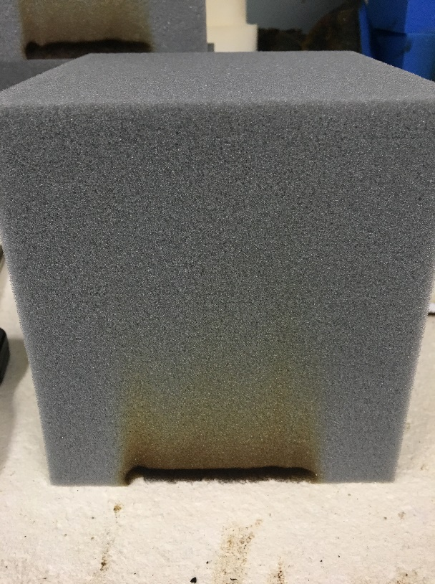
Figure 34A - System 1 with ½” of char. All tests turned out the same. The actual charring is the black at the bottom of the cube. The brown above it is just smoke residue from the cigarette.

System 2
The results are the same as System 1. No flames occurred during the test and charring was under ½”. The only difference was slightly more mass loss but still insignificant.

Cube System | Test Number | Initial Mass (g) | Final Mass (g) | Time (s) | Mass Loss (g) | Mass Loss Rate (g/s)
System 2 | 1 | 104.5 | 104.02 | 1375 | 0.48 | 0.000349
 | 2 | 104.68 | 104.59 | 1290 | 0.09 | 0.000070
 | 3 | 104.42 | 104.3 | 1330 | 0.12 | 0.000090
 | 4 | 103.78 | 103.67 | 1340 | 0.11 | 0.000082
 | 5 | 105.69 | 105.62 | 1365 | 0.07 | 0.000051
 | 6 | 106.06 | 105.94 | 1305 | 0.12 | 0.000092
Table 15A - System 2 Cigarette Data
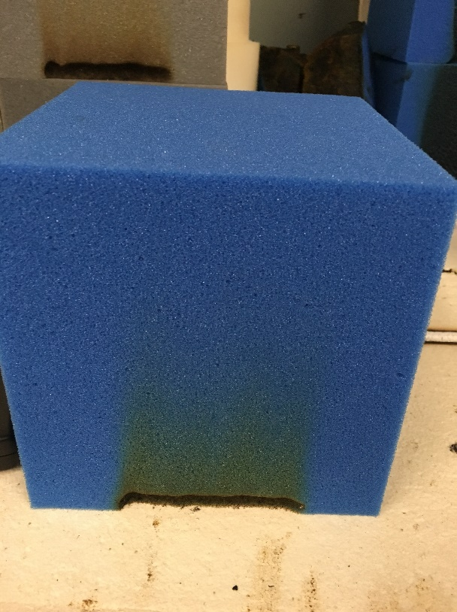
Figure 35A - System 2 with ½” of char. All tests turned out the same.

System 3
As with System 1 and 2 there was no flame and the char height was consistently ½”. Mass loss was closer to that of System 1.

Cube System | Test Number | Initial Mass (g) | Final Mass (g) | Time (s) | Mass Loss (g) | Mass Loss Rate (g/s)
System 3 | 1 | 118.14 | 118.05 | 1580 | 0.09 | 0.000057
 | 2 | 122.85 | 122.73 | 1575 | 0.12 | 0.000076
 | 3 | 119.85 | 119.76 | 1550 | 0.09 | 0.000058
 | 4 | 123.3 | 123.21 | 1235 | 0.09 | 0.000073
 | 5 | 119.9 | 119.8 | 1570 | 0.1 | 0.000064
 |  | 123.53 | 123.34 | 1575 | 0.19 | 0.000121
Table 16A - System 3 Cigarette Data

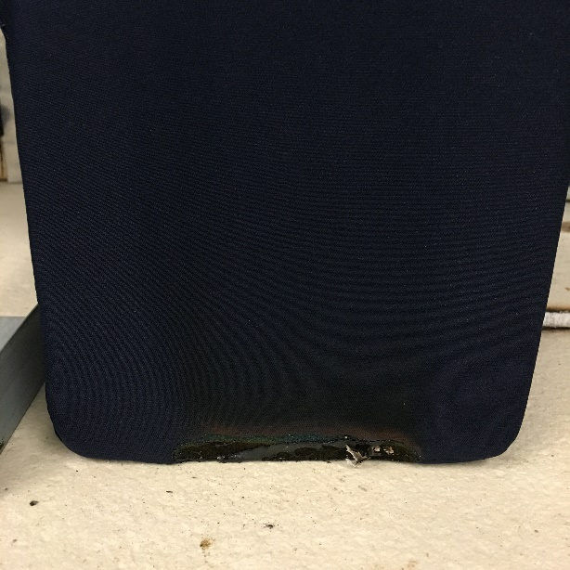
Figure 36A - System 3 with ½” of char. All tests turned out the same.

Intermediate scale Corner Tests
To simulate a small version of the conditions the pit cubes are in when piled in a gymnastics pit 20 cubes were used as a step up from the single cube tests in a 3’x3’x3’ corner made of gypsum board. Chicken wire was attached on the two walls of the corner 1.5 feet along each wall to create a space for the cubes to be thrown into and have them stack up rather than fall away. This allowed the cubes to fall randomly into place as well as observe the cubes at the fire progressed in case there was a drastic change in behavior from the single cube tests. The corner test was done six times. Each system was tested twice. The same super-critical condition found in the single cube tests was used. Each system was tested with the ignition at the top of the pile and at the bottom of the pile. Refer to Appendix B for more a detailed description of the set of and test procedure as well as the corner tests used to test the effectiveness of the set up.

System 1
The video for the top ignition test was unrecoverable.
Both tests started out with the 6 inch flame at 30 seconds of exposure. Bottom and top ignitions developed very slowly. After the first 60 seconds the initial cube is still the only one burning for the top ignition test while the bottom ignition test had 2 cubes burning at that point, Figure 38. 150 seconds into the tests top ignition test only spread to a few surrounding cubes, Figure 39. The fire quickly developed and then decayed from 3.5 to 6 minutes for both tests but a few smaller flames remained for another 4.5 minutes for the bottom ignition test and 5 minutes for the top ignition test making the time to flame out 10:34 for the bottom ignition and 11:21 for the top ignition.

The height indicator gives heights above the floor. The base of the cube pile is 1’ above the floor.
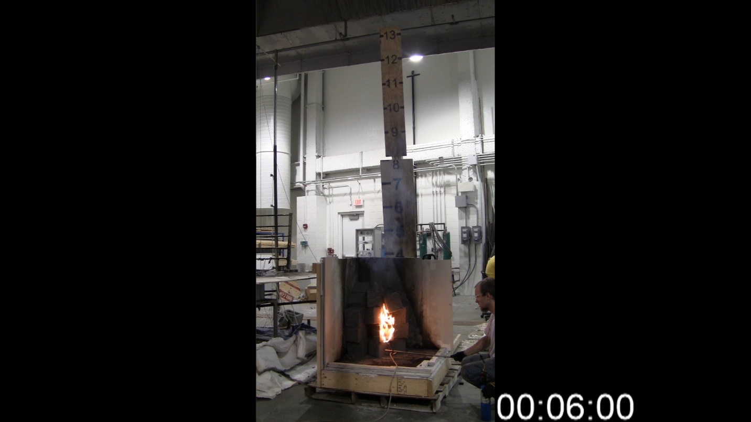
Figure 37A - The flame from the Bunsen Burner spreads upwards over 2 cubes due to the 6 inch flame height.

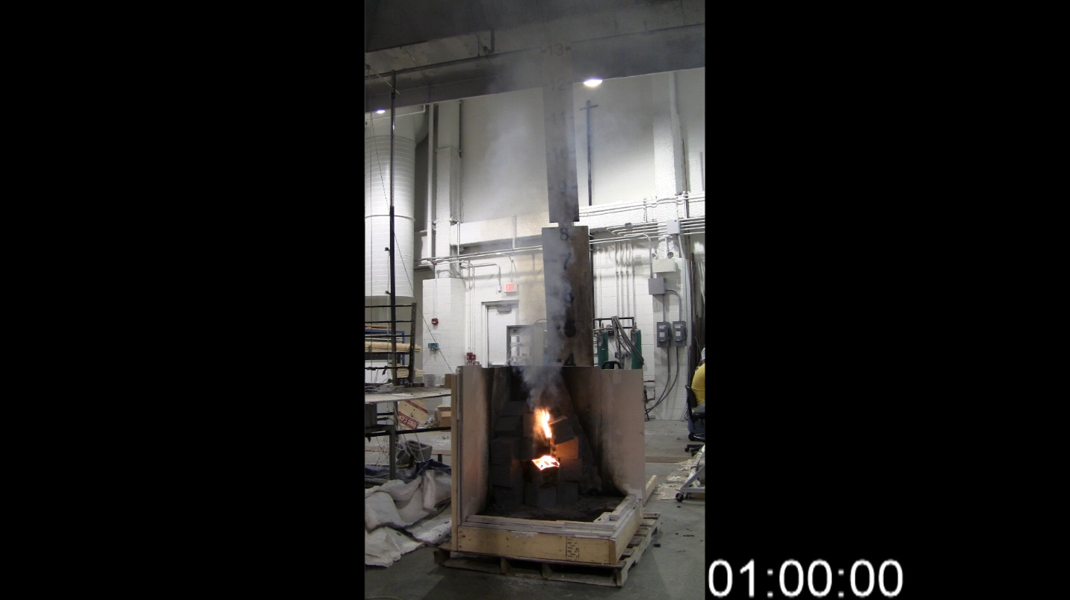
Figure 38A - The flame burns on the top edge of the cube initially exposed to the burner. The cube above it also continued to bur and drips onto the cube below that is already burning.

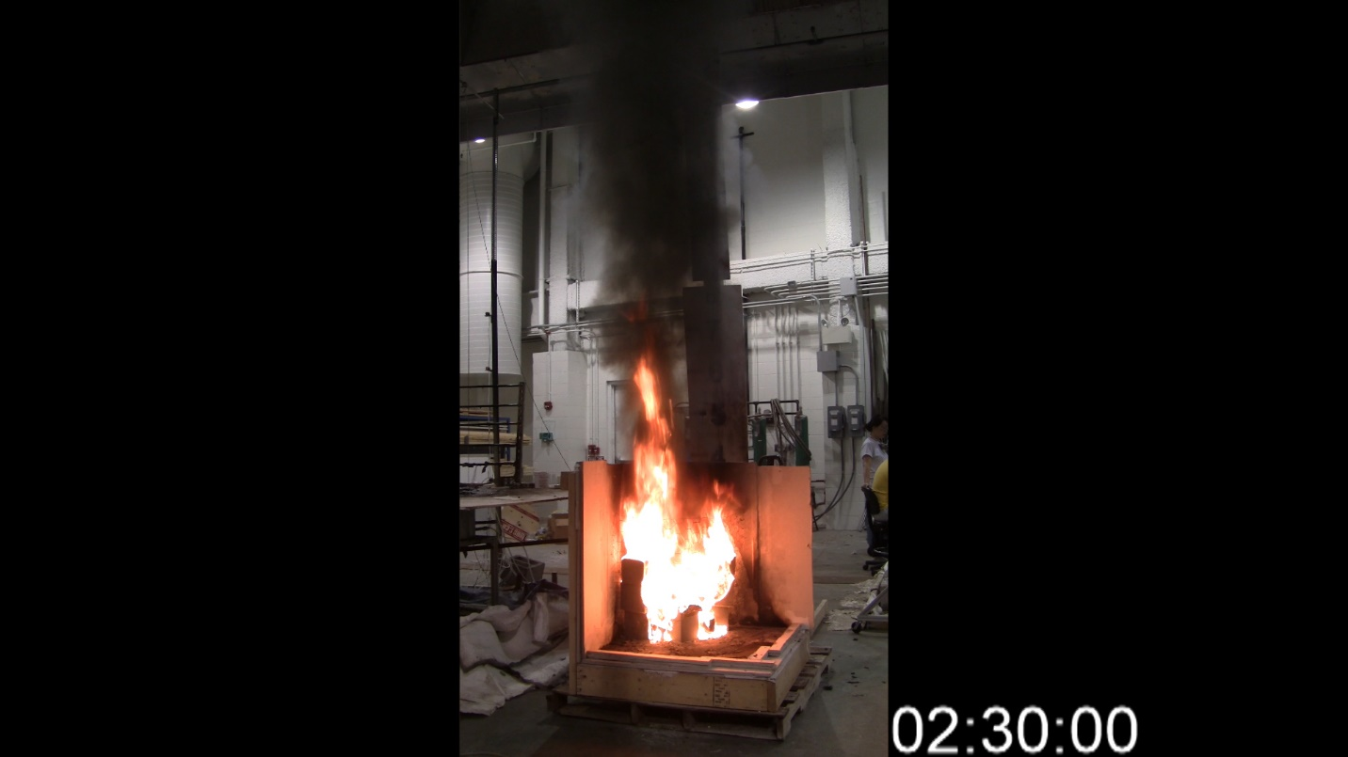
Figure 39A - At the same time that the single cube tests were extinguish, all of the cubes have started burning and producing a 6-7 foot flame height from the base of the pile.
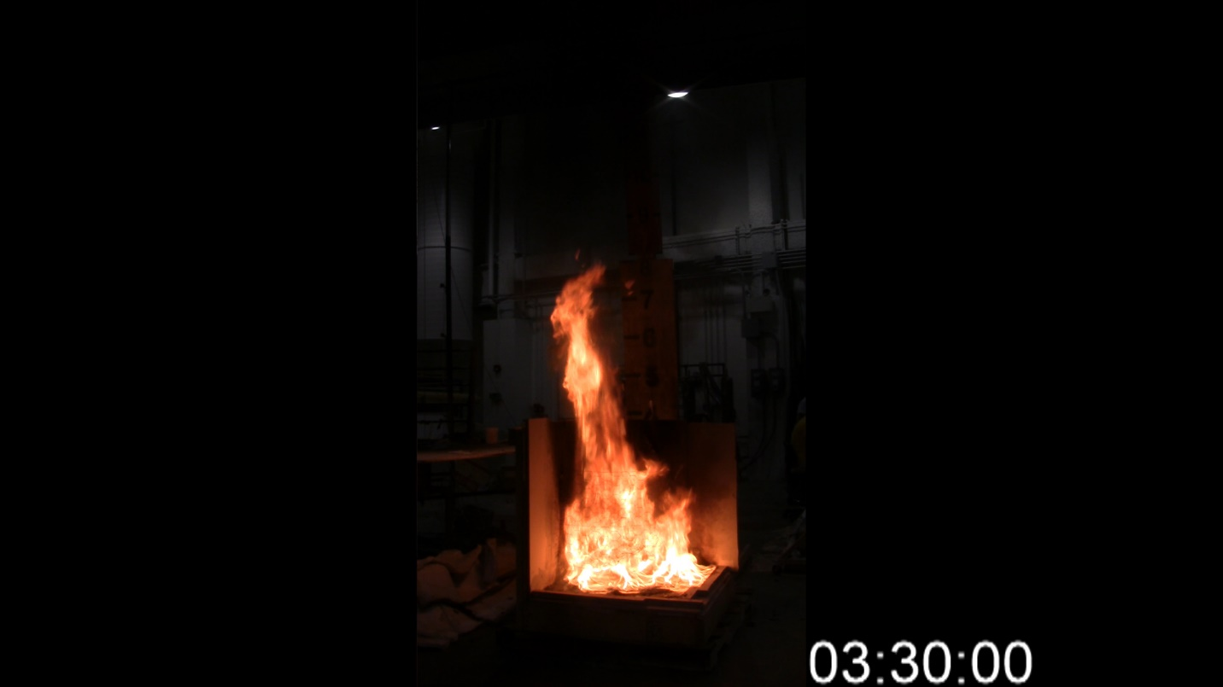
Figure 40A - The pile of cubes quickly melts into a pool and continues to burn with a 6-7 foot flame height.

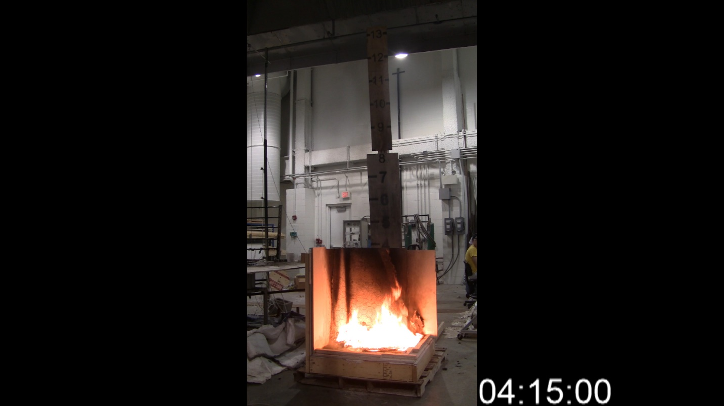
Figure 41A - The fire burns down as the fuel is used up. The flame height is now about 18 inches.
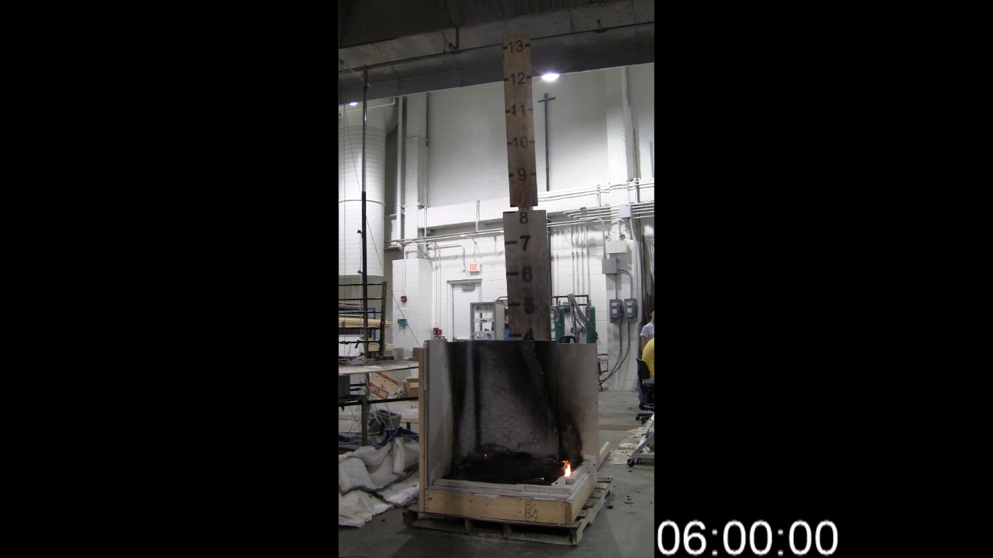
Figure 42A - The last of the fuel continues to burn out slowly until finally extinguishing after 10:34.

System 2
Both tests used a 1.5 inch flame that was applied for 18 seconds. The bottom ignition test spread much faster than the top ignition. In Figure 44 after 60 seconds the bottom ignition pile has spread to most of the cubes while the top ignition pile is still only burning on the cube that was exposed to the Bunsen Burner. At 150 seconds the bottom ignition pile has melted down into a pool fire while the top ignition pile is still not entirely involved, see Figure 45. The bottom ignition pile then dies out and only has a few small flames from 5 minutes to 8.5 minutes. During this time the top ignition reaches full involvement of the 20 cubes and then dies out, Figures 46-48. The bottom ignition test reached flame out after 6:30 while top ignition lasted 9 minutes. Both tests had nothing remaining after flame out.

Bottom Top
Figure 43A - As the Bunsen Burner is applied both cubes burn in a consistent manner to the single cube tests.

Figure 44A - The bottom ignition test quickly grows while the top ignition still has only the initial cube burning.

Bottom Top
Figure 45A - The bottom ignition test has almost entirely melted into a pool while the top ignition test is still growing.

Figure 46A - The bottom ignition test has almost died out while the top ignition test has just reached its peak.

Bottom Top
Figure 47A - The bottom ignition test has reached flame out and the top ignition test is running out of fuel.

Figure 48A - The top ignition test has reached flame out.

System 3
These tests used the same super critical condition as system 2. Both tests progressed at the same rate. After a minute the spread of both tests was slow and only had ignited a few cubes, Figure 50. After 150 seconds most of the cubes have started and burn for both tests as well as very similar flame heights, Figure 51. This remains the same throughout the reminder if the test with the bottom and top ignition having very similar burn patterns, Figures 52-54. Both tests lasted just over 10.5 minutes leaving only a small amount of residue from the covers.

Bottom Top
Figure 49A - Both tests are half way through the exposure time of the Bunsen Burner.

Bottom Top
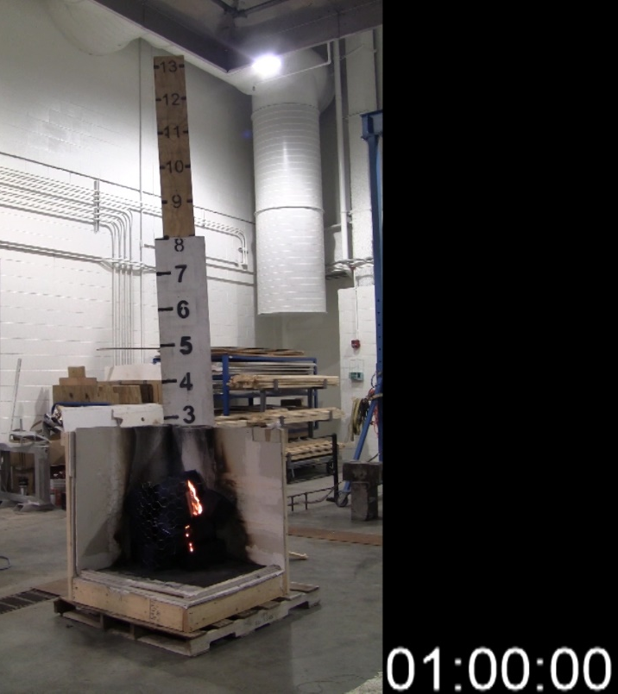
Figure 50A - The bottom ignition test has grown but is still only burning the initial cube while the top ignition test is dripping on to the lower cubes.

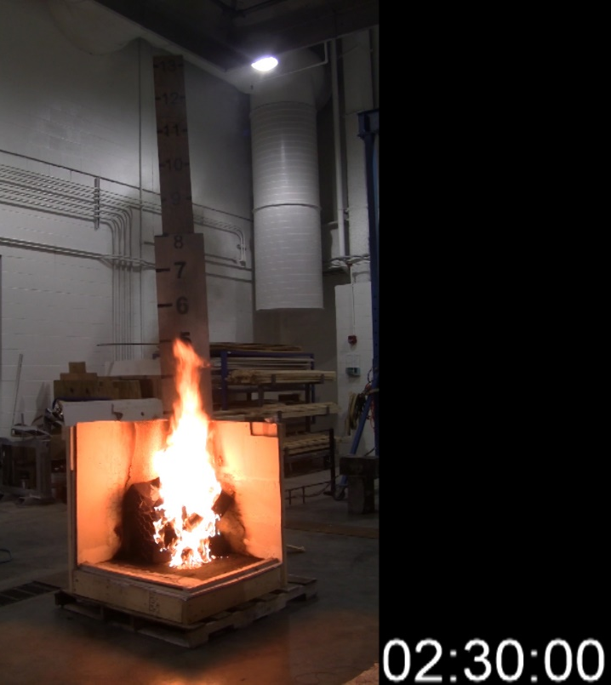
Figure 51A - Both tests have now spread but the top ignition test has more cubes involved and a flame height 2 feet taller than the bottom ignition test.
Bottom Top
Figure 52A - The bottom ignition test has reached its peak while the top ignition test is decaying.

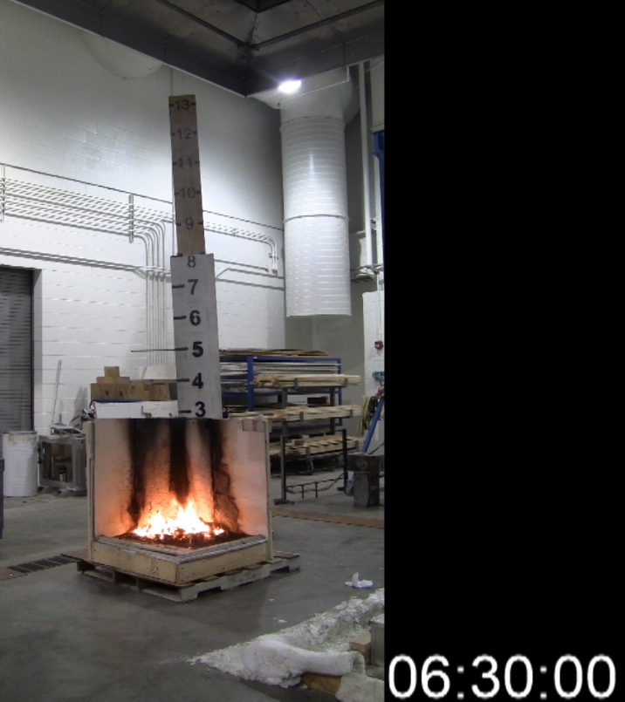
Figure 53A - Both tests have died down and are using up the remaining fuel.

Bottom Top
Figure 54A - The last of the flames for both tests.

Intermediate Scale Pit Tests
To further increase the scale of the tests a 3’x3’x2’ tall “mini-pit” was constructed out of gypsum board. The pit was filled with 70 cubes which were all tossed into the pit similarly to the corner. Each system was tested once with the ignition being at the top using the same super-critical conditions from the single cube and corner tests.

System 1
A cube at the top of the pile near the center was exposed to the super-critical condition for System 1, a 6 inch flame applied for 12 seconds. The flame spreads very slowly for the first 5:30 and only ignites 3 of the cubes around it, Figures 55-57. Once one of the cubes below the top layer starts to burn, the fire spreads much more rapidly across the top half of the pit. By 7:30 the pit is fully involved and continues to burn with an 8-12 foot flame height until 10 minutes into the test, Figures 58-61. At 10 minutes the fire dies down significantly then continues to burn in the bottom of the pit until flame out at 14:15, Figure 62-63.

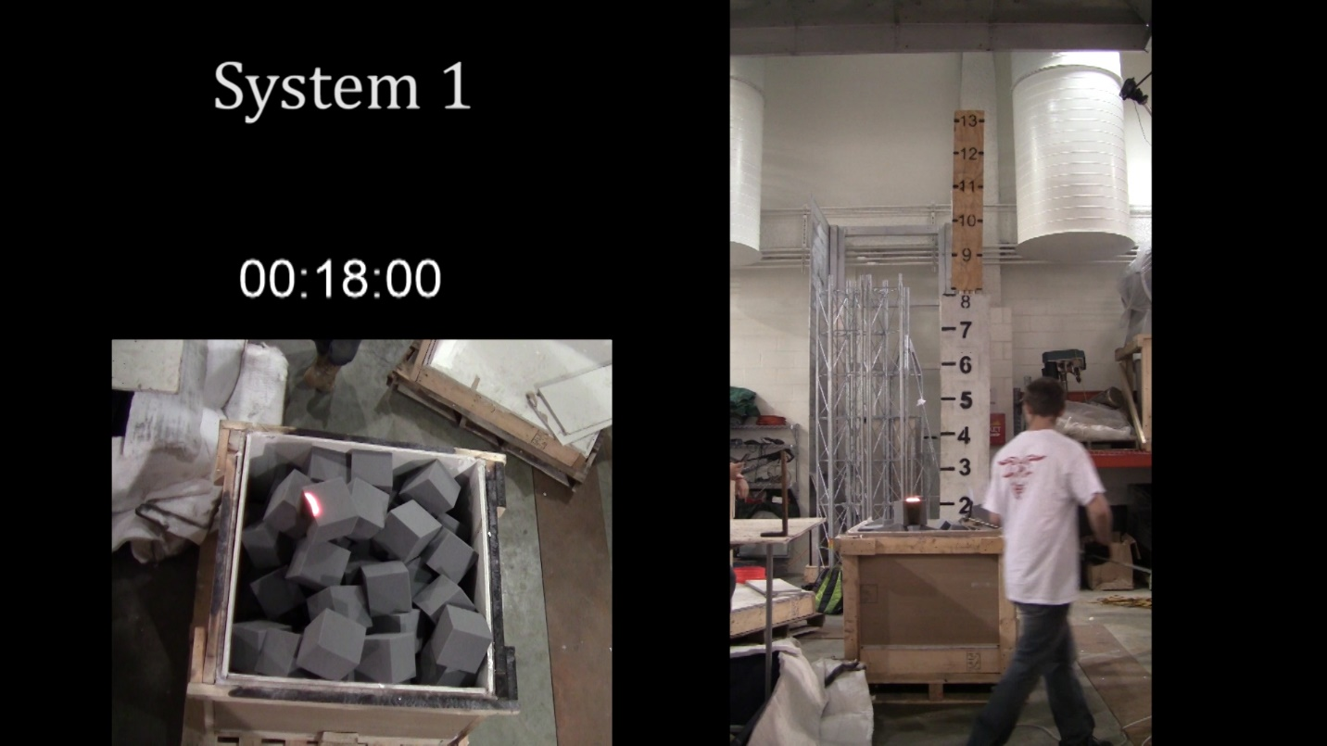
Figure 55A - 6 seconds after the burner is removed the flame remains just along the top of the initial cube.
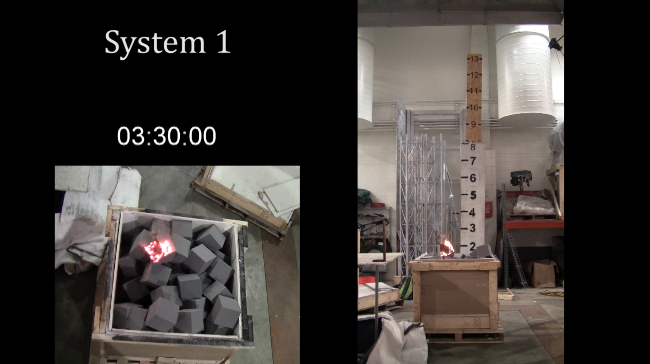
Figure 56A - The initial cube is still the only one burning.
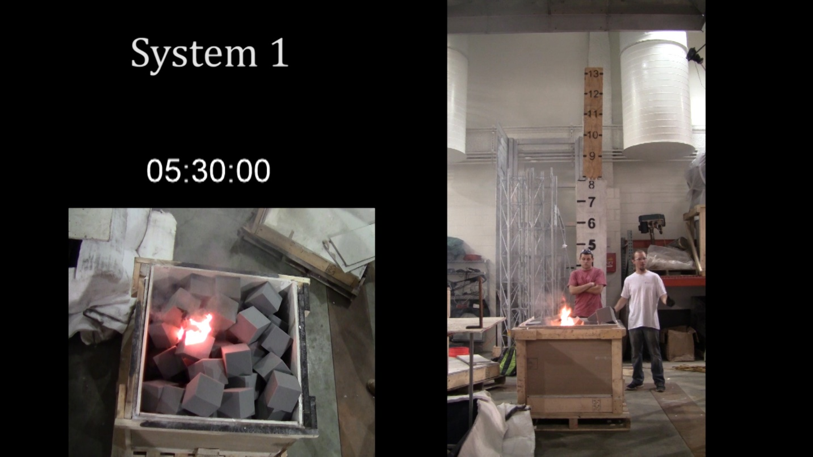
Figure 57A - The fire has just started burning a few cubes around the initial cube that was exposed.
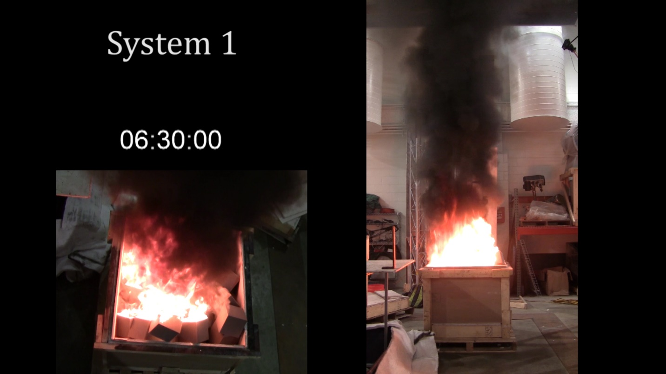
Figure 58A - The fire quickly spread to most of the cubes on the top creating a 2 foot flame height.
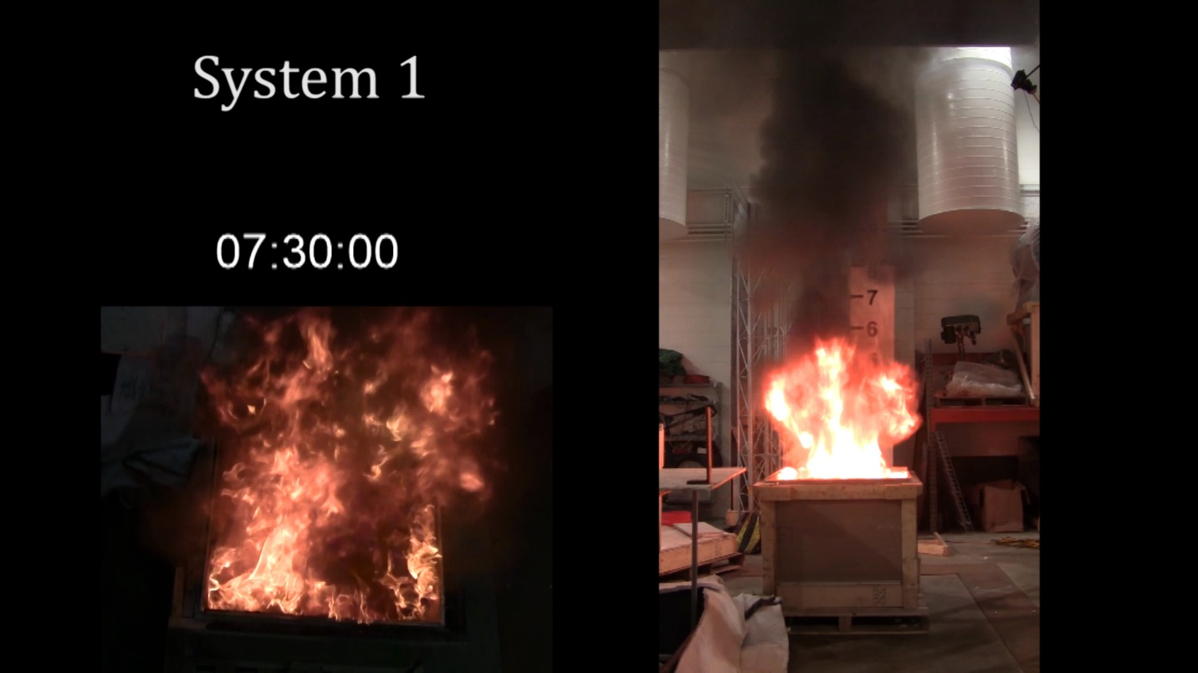
Figure 59A - The pit is fully involved and now limited by the amount of oxygen that can get into the pit.
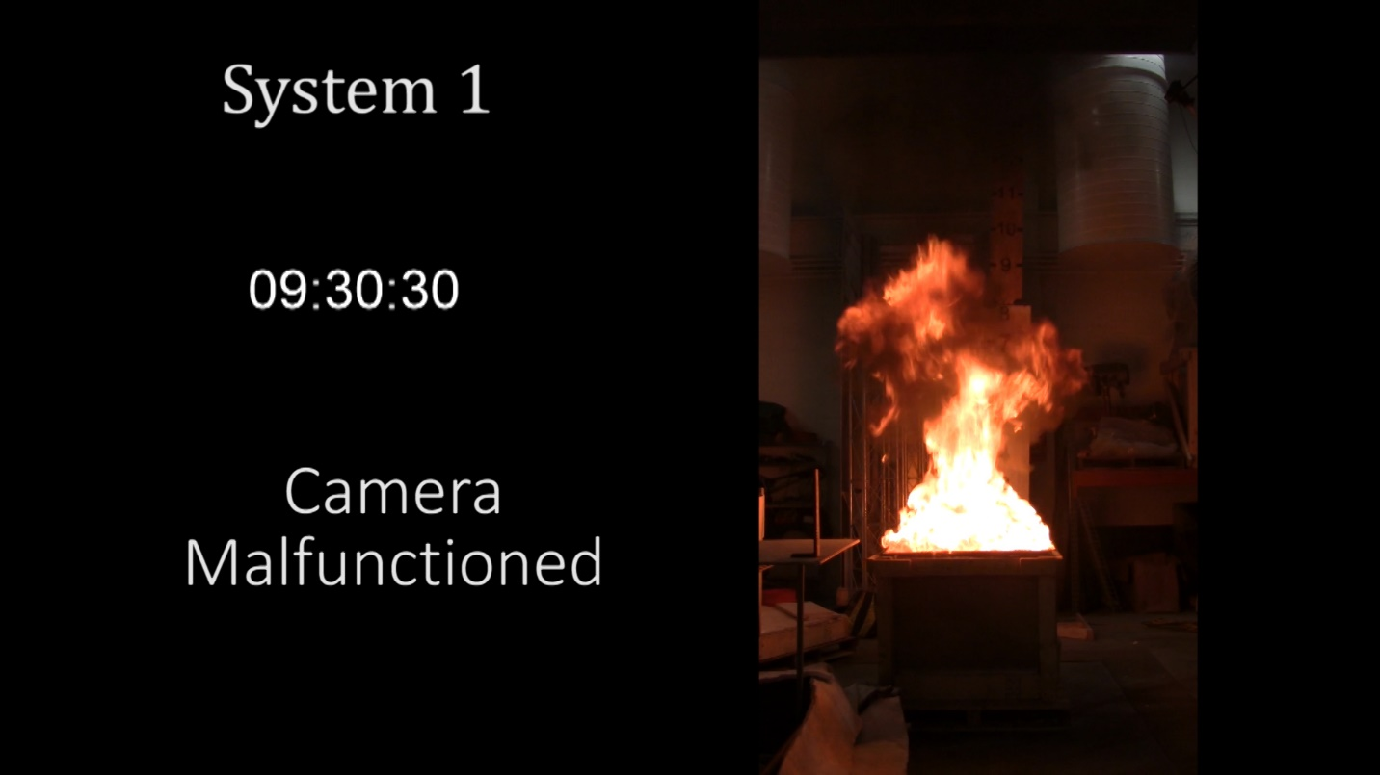
Figure 60A - The fire continues to burn for several minutes at consistent 10-12 foot flame height.
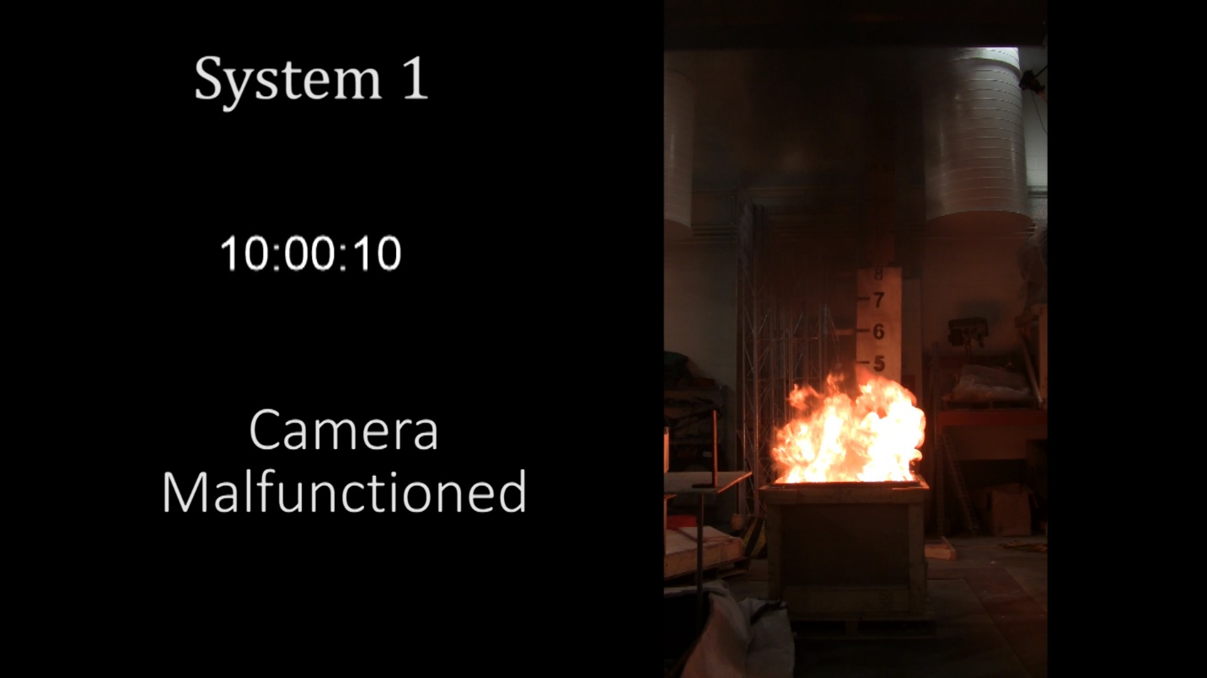
Figure 61A - The fire dies down and starts to have flame inside of the pit.
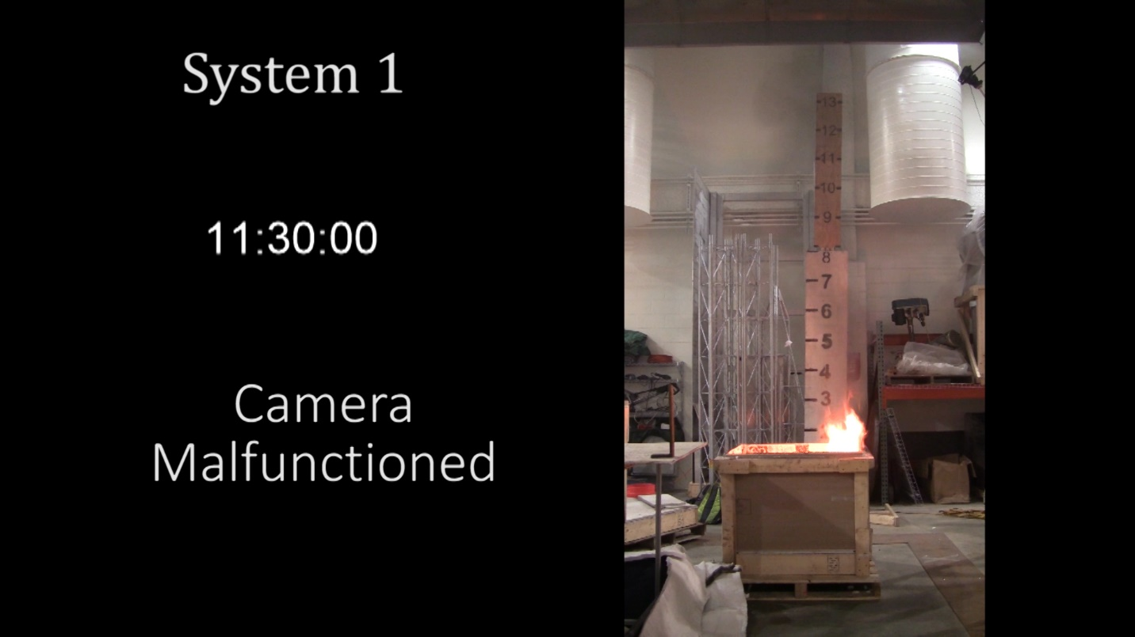
Figure 62A - The last of the fuel has pooled in the corner and produces the last of the flames that reach out of the pit.
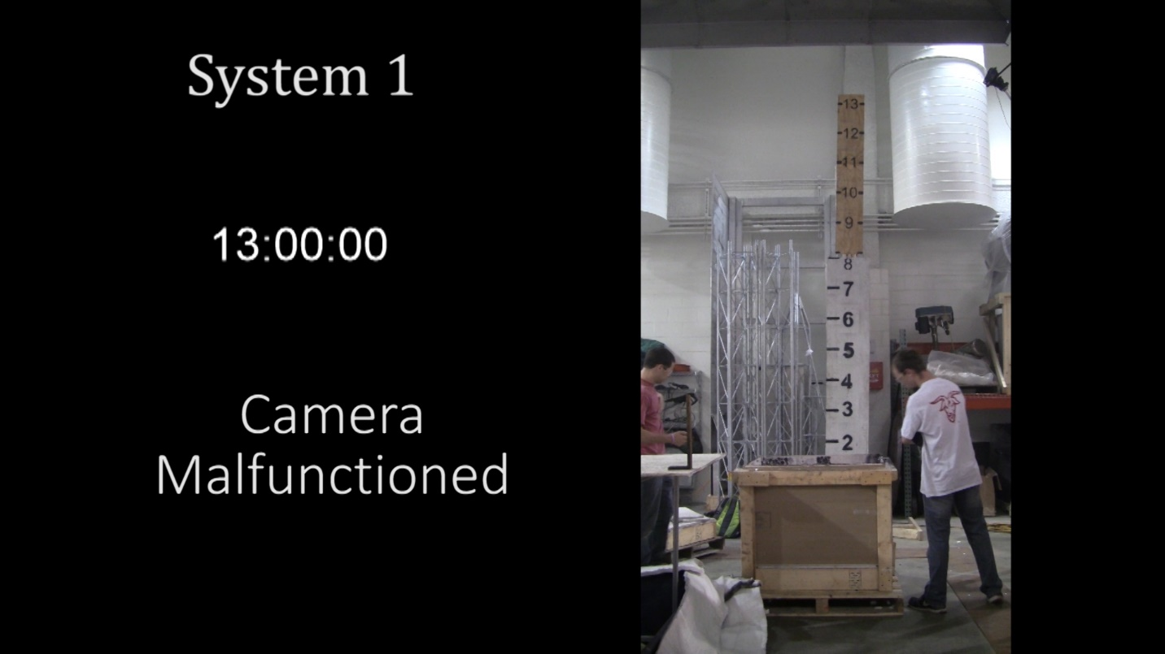
Figure 63A - The remaining flames are around the bottom of the pit and barely an inch in height until finally reaching flame out at 14:13.

System 2
A cube at the top of the pile near the center was exposed to the super-critical condition for System 2, a 1.5 inch flame applied for 18 seconds. In the first 60 seconds of the test there is very little fire spreading, Figure 64-65. The second 60 seconds has exponentially greater fire growth until the fire peaks at 3 minutes and continues to burn at this max burning rate until 5:20 when it quickly dies down, Figures 66-69. Then there are only a few small flames that linger in the bottom until flame out at 10:14. The test results in 100% of the fuel being consumed.

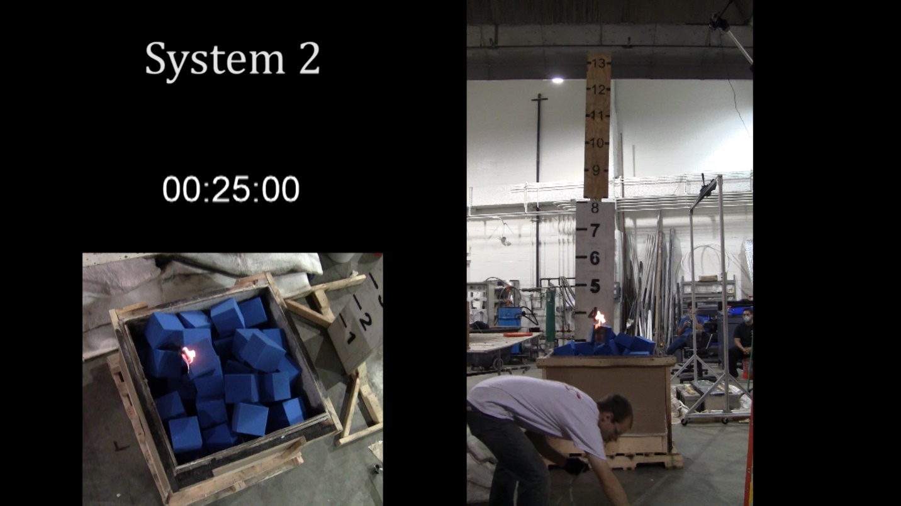
Figure 64A - The top of the initial cube has continued to burn for 7 seconds after the Bunsen Burner was removed.

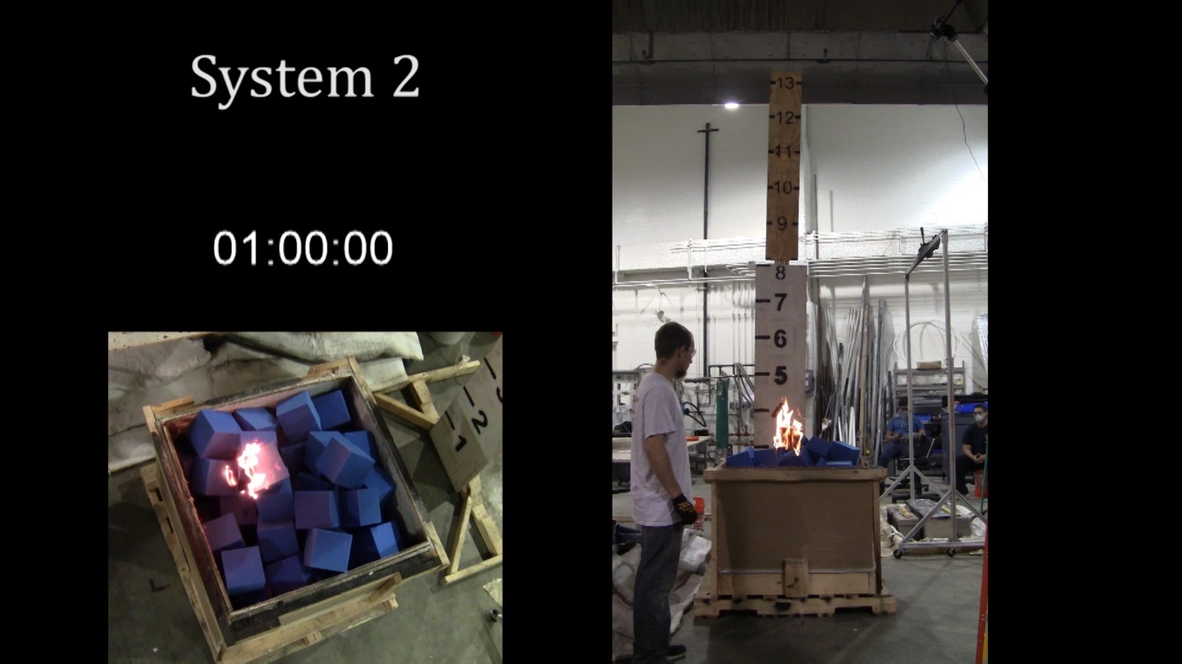
Figure 65A - The fire spreads slowly to the cubes under the initial one.
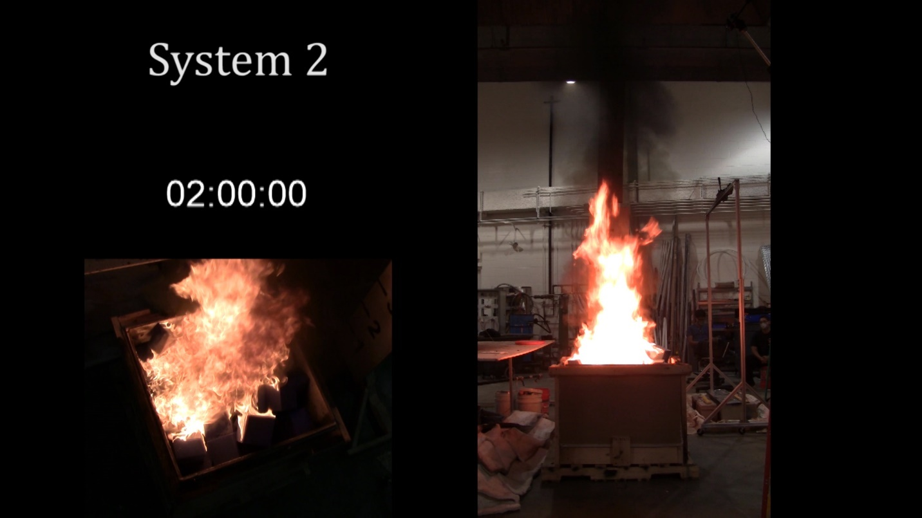
Figure 66A - The fire develops more rapidly and spreads across most of the pit.
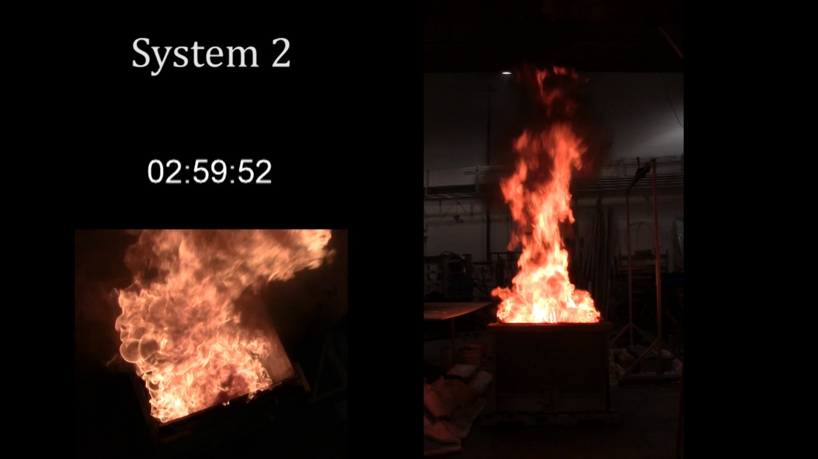
Figure 67A - The pit has reached full involvement with a 12-14 foot flame height.
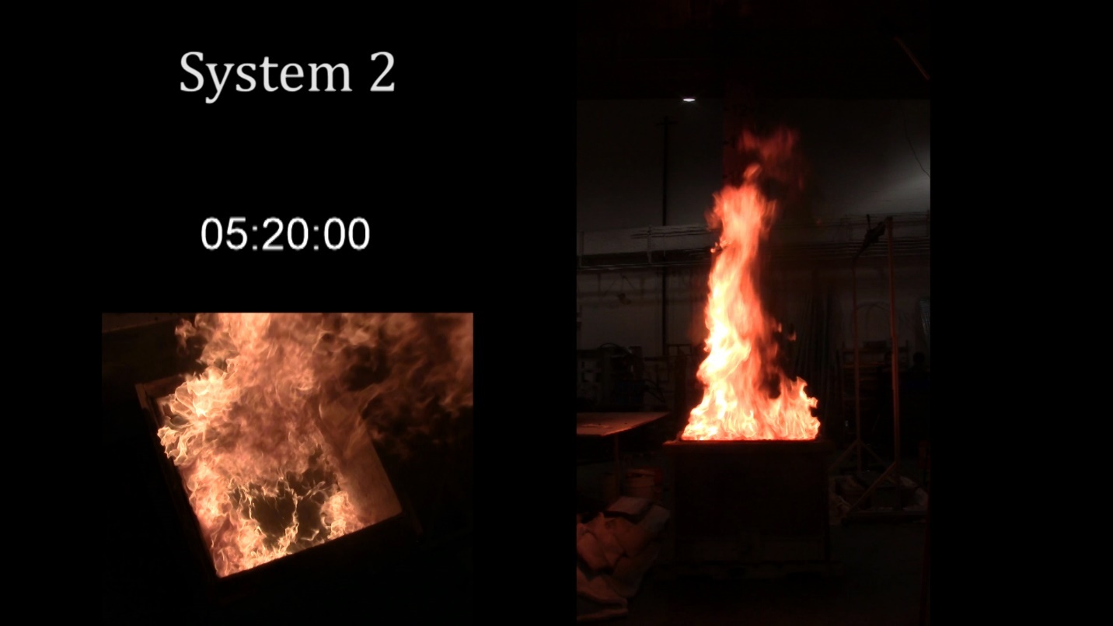
Figure 68A - The fire starts to burn down into the pit as the fuel starts to run out.

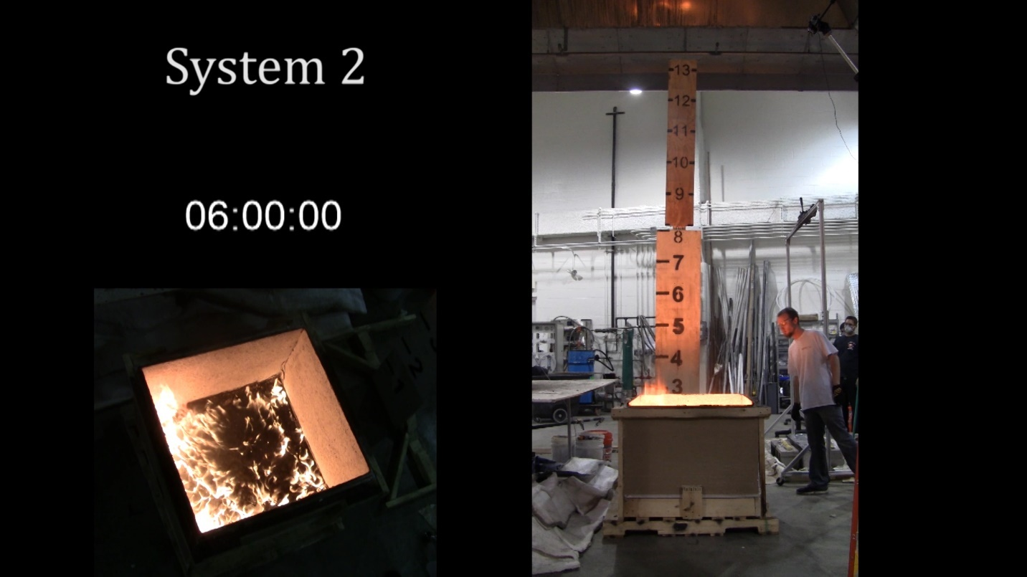
Figure 69A - The last of the fuel burns out as the flame is mostly contained inside of the pit.
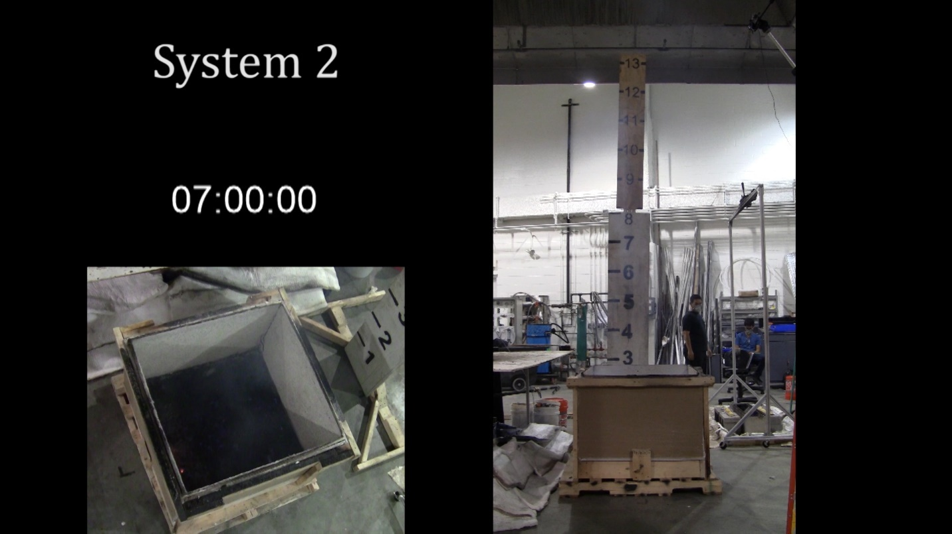
Figure 70A - A few remaining flickers of flame remain until flame out at 10:14.

System 3
A cube at the top of the pile near the center was exposed to the super-critical condition for System 3, a 1.5 inch flame applied for 18 seconds. After the burner was removed the fire spread very slowly at first, Figures 71-72. Then it quickly escalated to a very large fire, 10-12 feet tall, that burned very rapidly, Figures 73-75. It died down after 5:30 and then continued to burn the rest of the fuel for another 5 minutes, Figures 76-77. Effectively 100% of the fuel is consumed during the test. The only remains are likely the Velcro that was on half of the covers which did not completely burn. However, the percentage of remaining mass to the initial fuel load mass is below 1% and can be ignored.

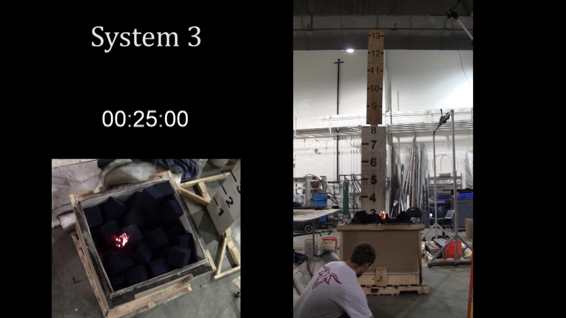
Figure 71A - 7 seconds after the burner was removed the flames are still small but have dripped down on to the cubes directly below the cube initially exposed to the burner.
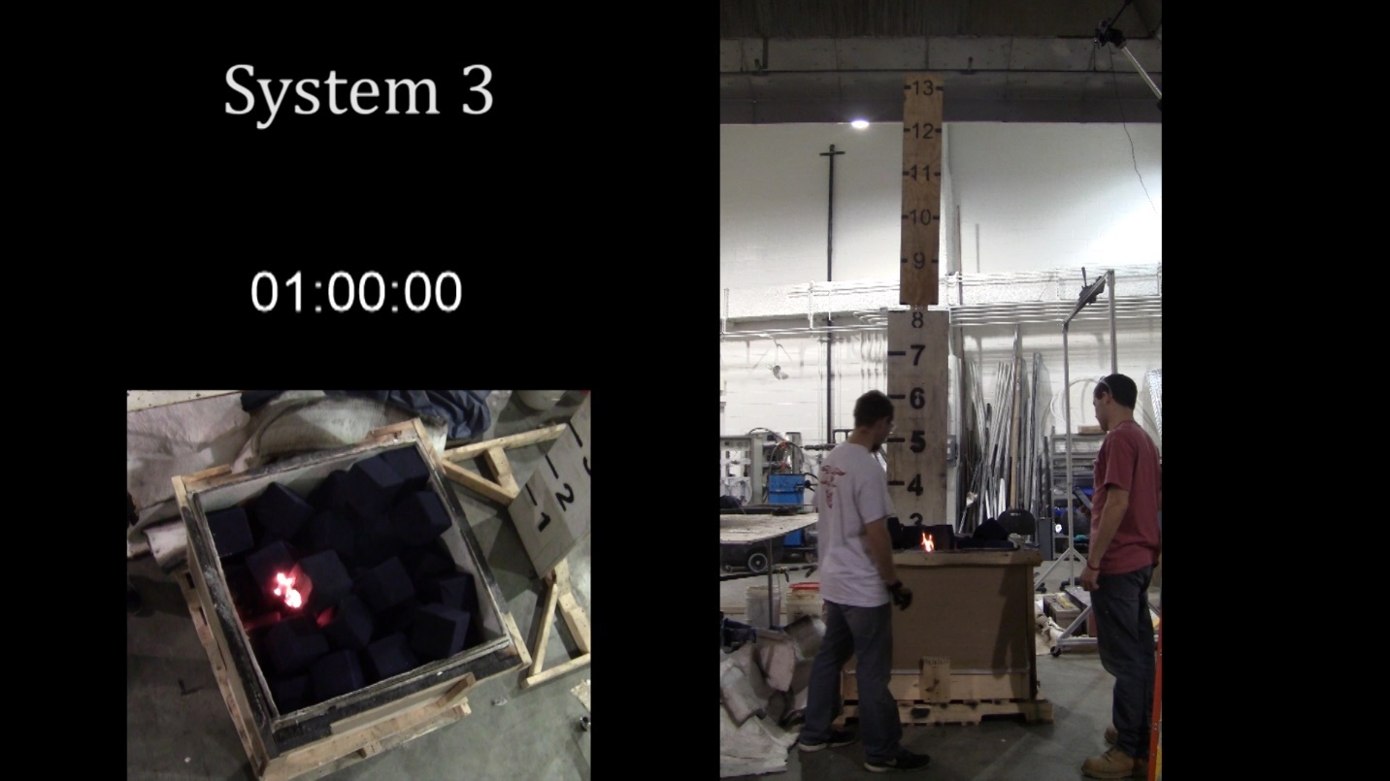
Figure 72A - The fire has spread minimally after a minute.
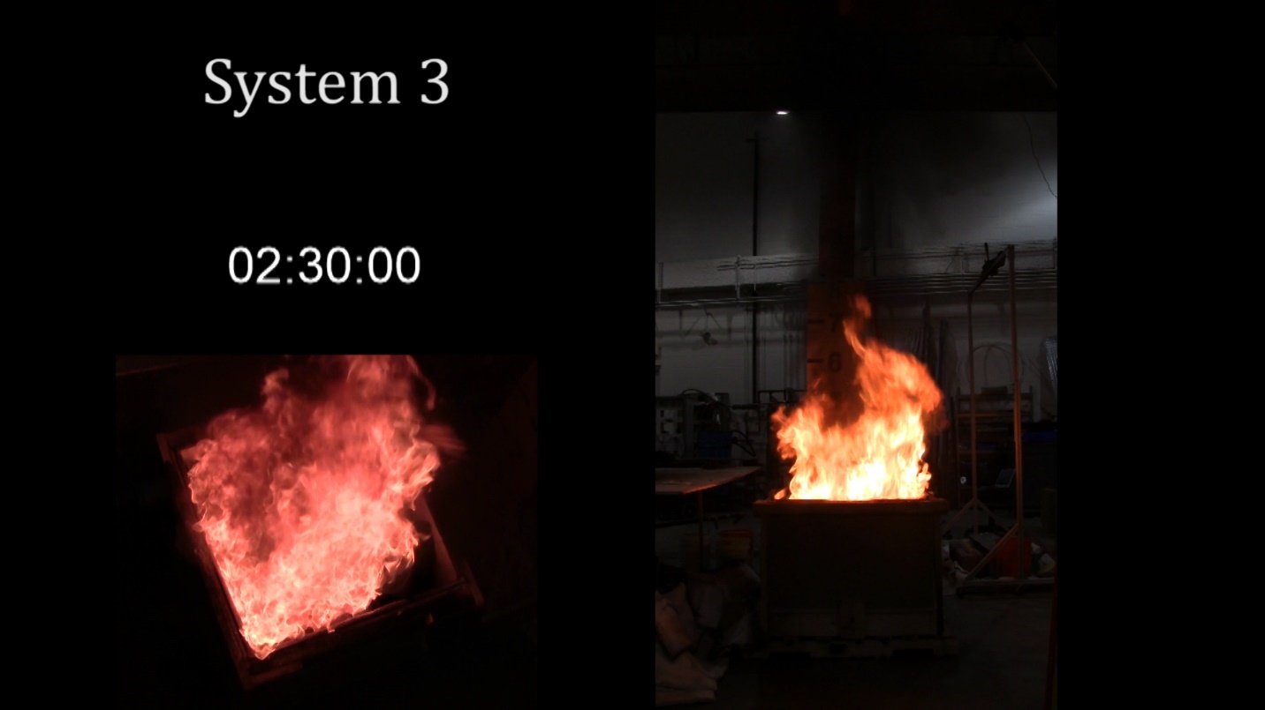
Figure 73A - Very quickly the top layer of cubes ignites producing a 5 foot flame height.
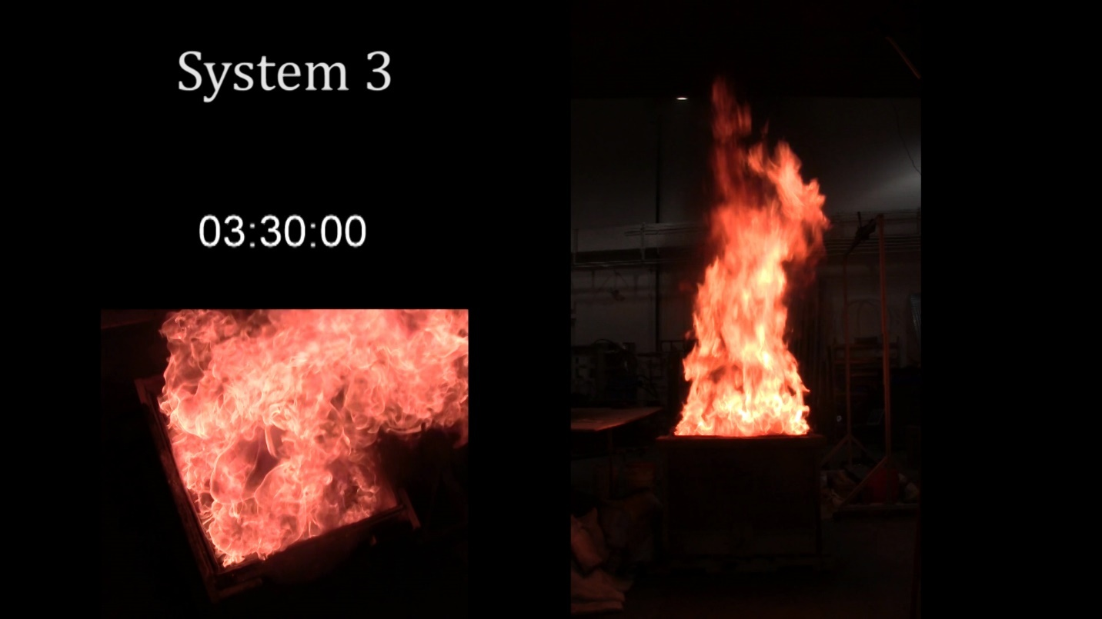
Figure 74A - The fire has reached its peak involvement with a flame height of 10-12 feet.
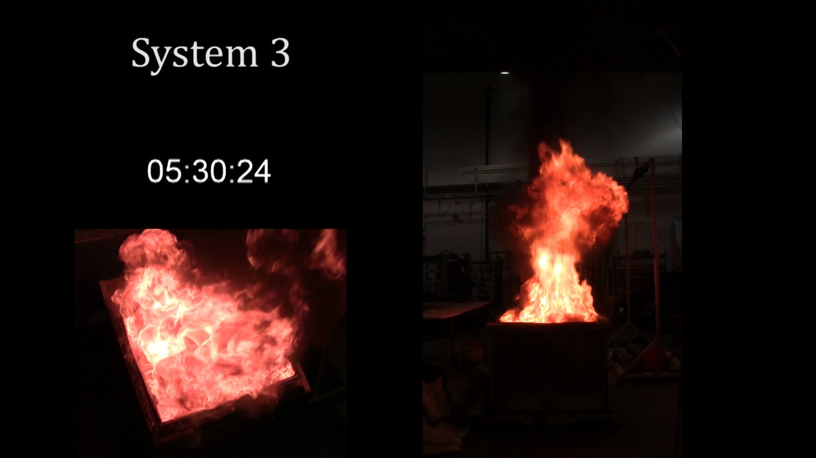
Figure 75A - The fire starts to burn down in the pit as it dies down.
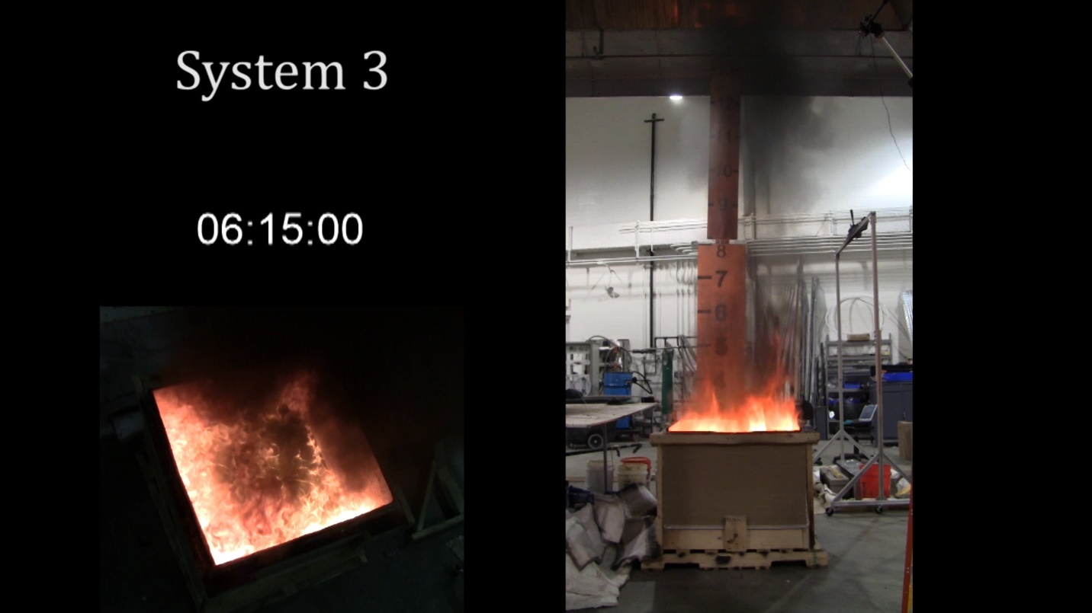
Figure 76A - The majority of remaining fuel is around the bottom edges with the flame only getting about a foot above the top of the pit.
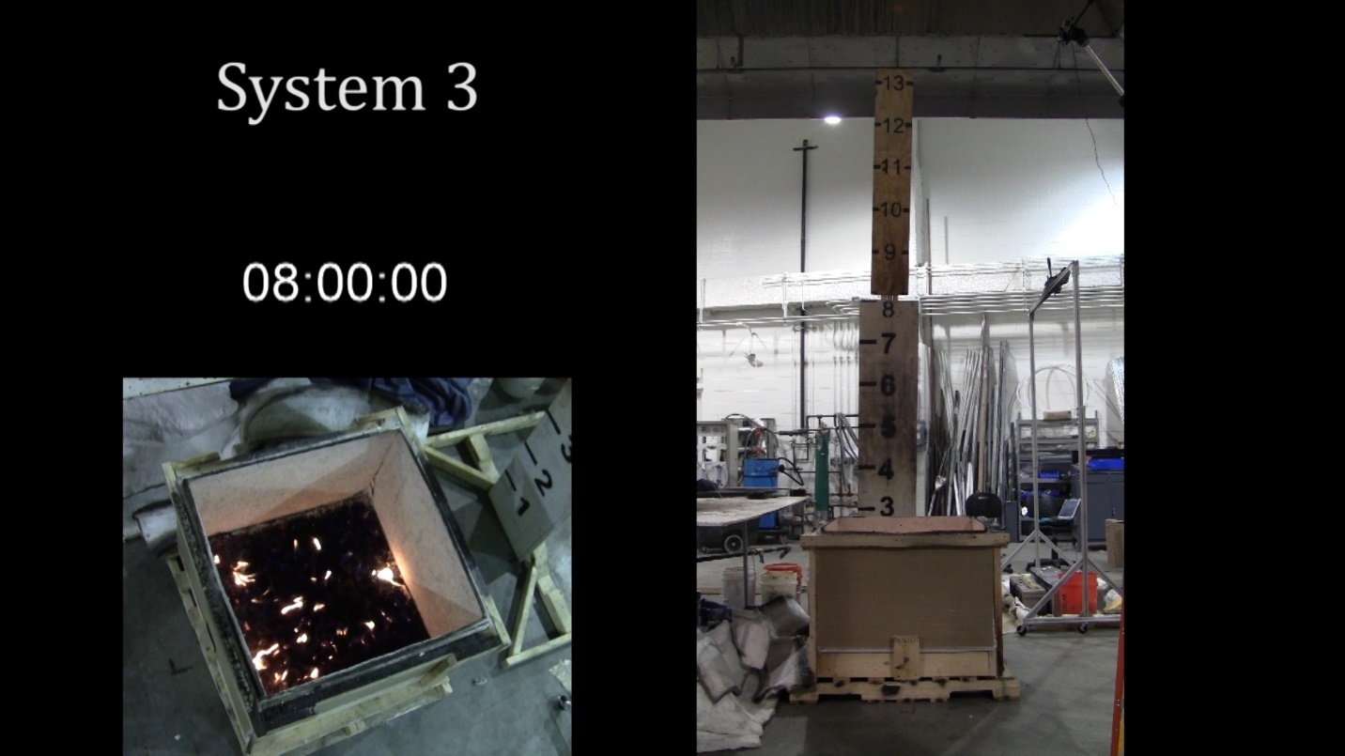
Figure 77A - The last of the flames flicker at the bottom until flame out at 10:25.

Appendix B – Modified Bunsen Burner Test

Modified Bunsen Burner Test for Foam Cubes

Using a modified Bunsen burner test based on the California Technical Bulletin 117 (TB117) from 2000, individual cubes were subjected to a one and a half inch methane flame for twelve seconds. The cube was placed on a sheet of calcium silicate board three quarters of an inch above the top of the Bunsen burner. The cubed was placed such that half of an inch of the bottom face was off of the edge of the board. The flame height was set to a consistent one and a half inches using a flame height indicator made of rigid aluminum. Once the flame was set the burner was placed under the cube for exactly twelve seconds and then removed.

Burner Location Tests: For the test foam three locations of the Bunsen Burner were tested, (1) having the burner tangent to the face of the foam, (2) having the burner centered under the edge of the foam cube, and (3) having the burner centered under the ½”overhang of the cube. Each location was tested three times and filmed. The flame was 1 ½” tall with ¾” of the flame applied to the foam. The flame was applied for 12 seconds every time. Every one of the nine tests resulted in the same burn pattern. Initially the flame burned up the face of the cube in the center until the flame was removed. Then the flame burned along the top edge of the cube. Image A1 shows the burn path and flame at the top of each cube. The flame then burns down the face that initially received the flame and across the top of the cube. Image A2 shows the cube being burned down. Cubes were extinguished once the flame was an inch or two away from the bottom front edge. Image A3 shows all of the extinguished tests lined up for comparison (The order of the tests in this image is test 1-9 from right to left).

The only variation in the tests was the width of the flame burning up the face in the beginning. This width difference does not seem to be dependent on the location of the burner and the magnitude of the width difference is quite small. It did not change the way the way the cubes burned overall. Also all cubes burned at approximately the same rate.

Overall, the location of the Bunsen Burner seems to be negligible.

Tests
T1 – Burner set up tangent to the face of the cube #1.
T2 – Burner set up tangent to the face of the cube #2.
T3 – Burner set up tangent to the face of the cube #3.
T4 – Burner set up centered under the edge of the cube #1.
T5 – Burner set up centered under the edge of the cube #2.
T6 – Burner set up centered under the edge of the cube #3.
T7 – Burner set up centered under the half inch overhang of the cube #1.
T8 – Burner set up centered under the half inch overhang of the cube #2.
T9 – Burner set up centered under the half inch overhang of the cube #3.

Test Images and Diagrams
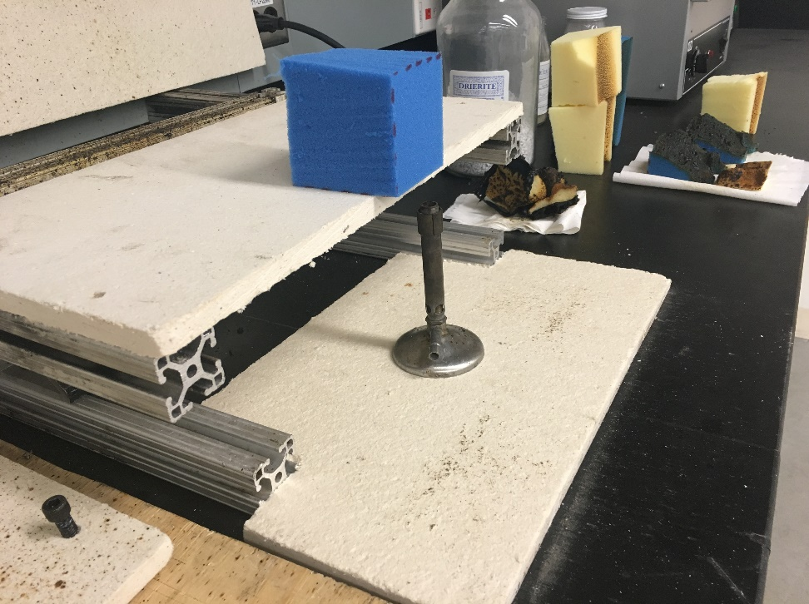
Figure 1B - Image of the test apparatus.

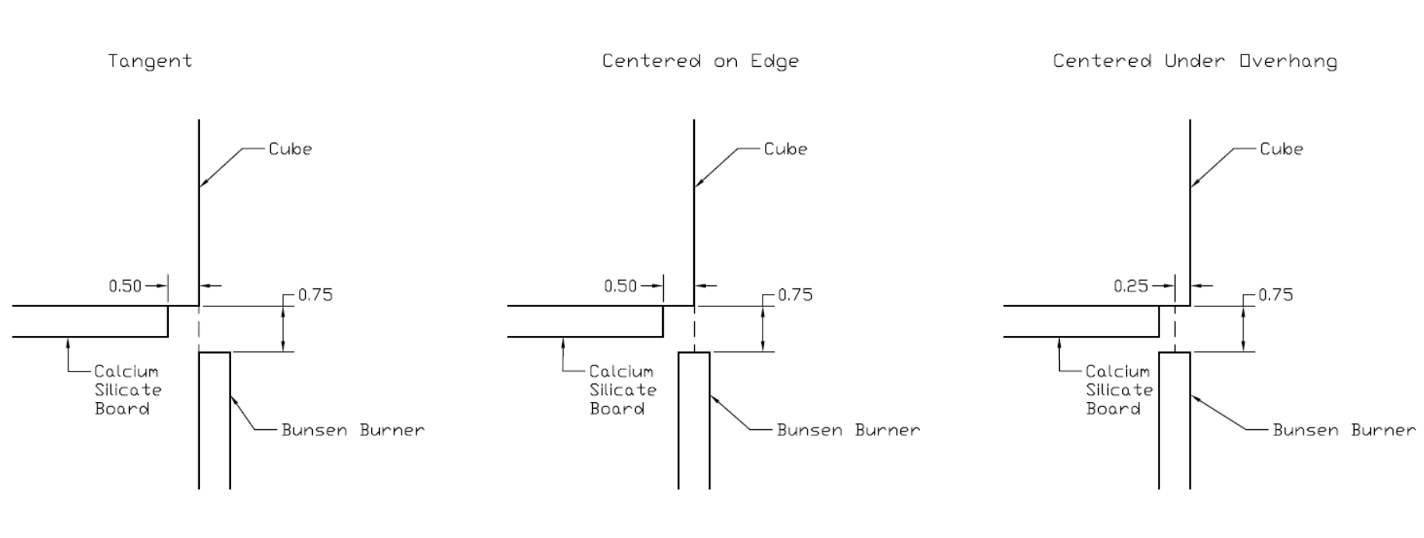
Figure 2B - Diagrams of the three burner locations. Measurements are in inches.

In all images the top row is Tangent (T1, T2, T3), the middle row is Centered Under Edge (T4, T5, T6), and the bottom row is Centered Under Overhang (T7, T8, T9).

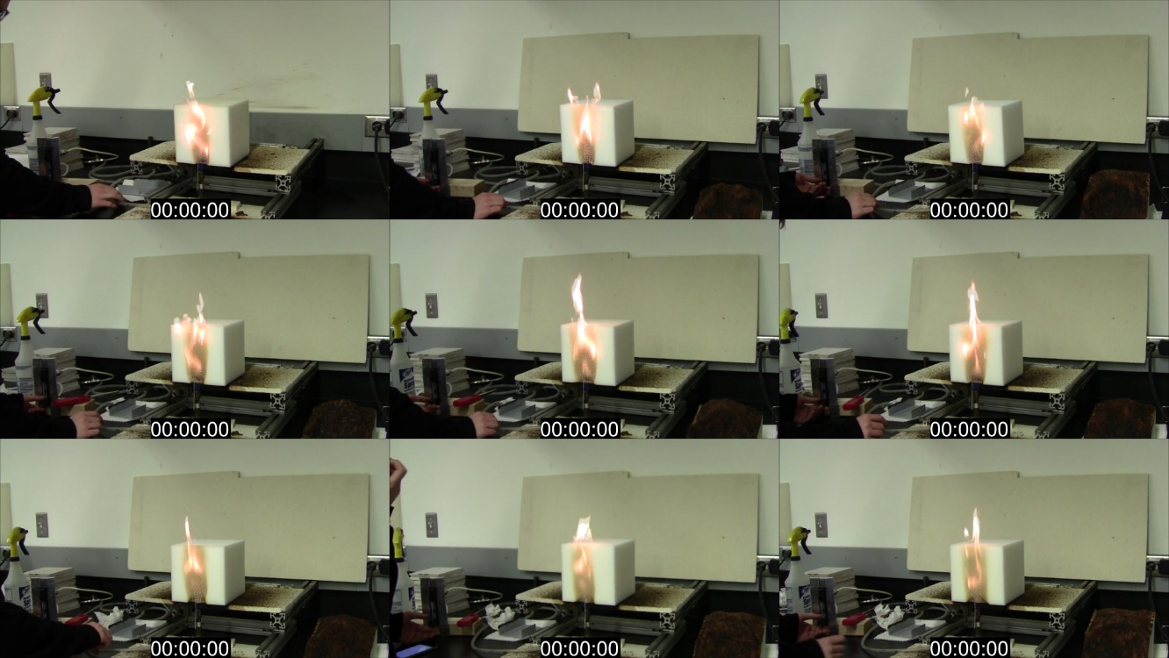
Figure 3B - Each cube about half way through the initial 12 second flame application.
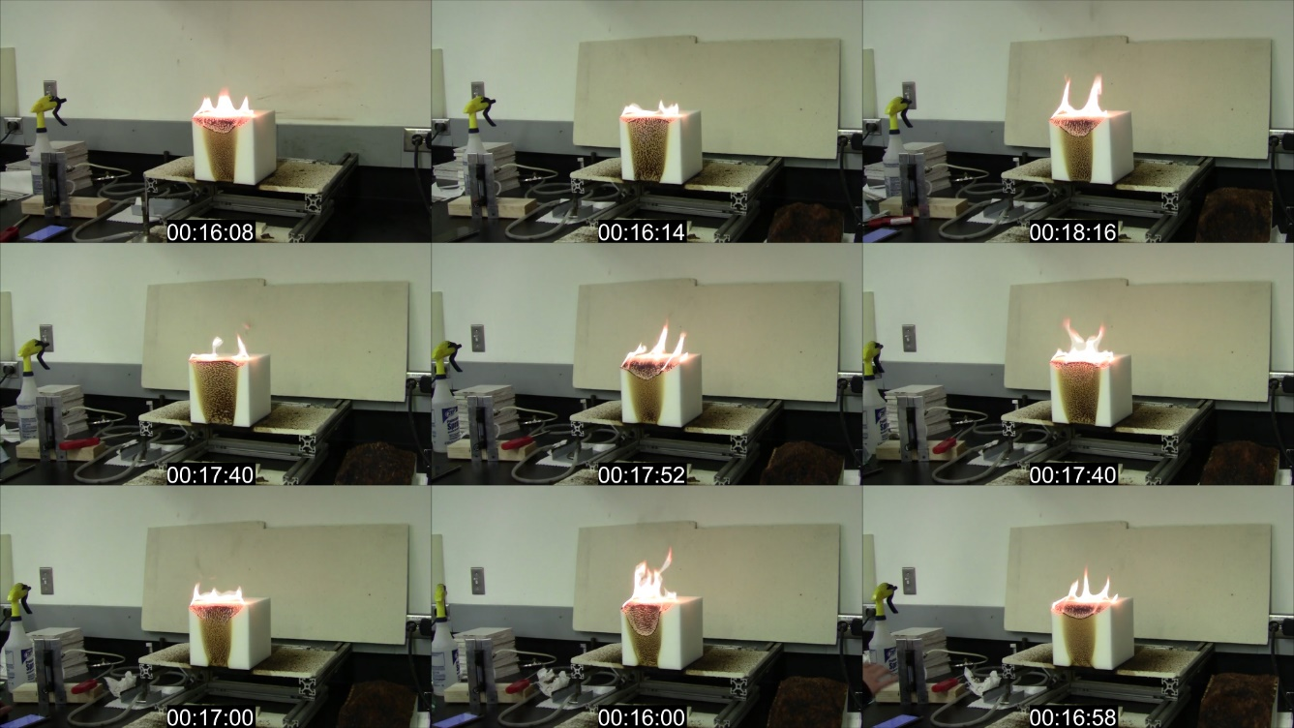
Figure 4B - After the flame is removed the fire only burns on the top edge.

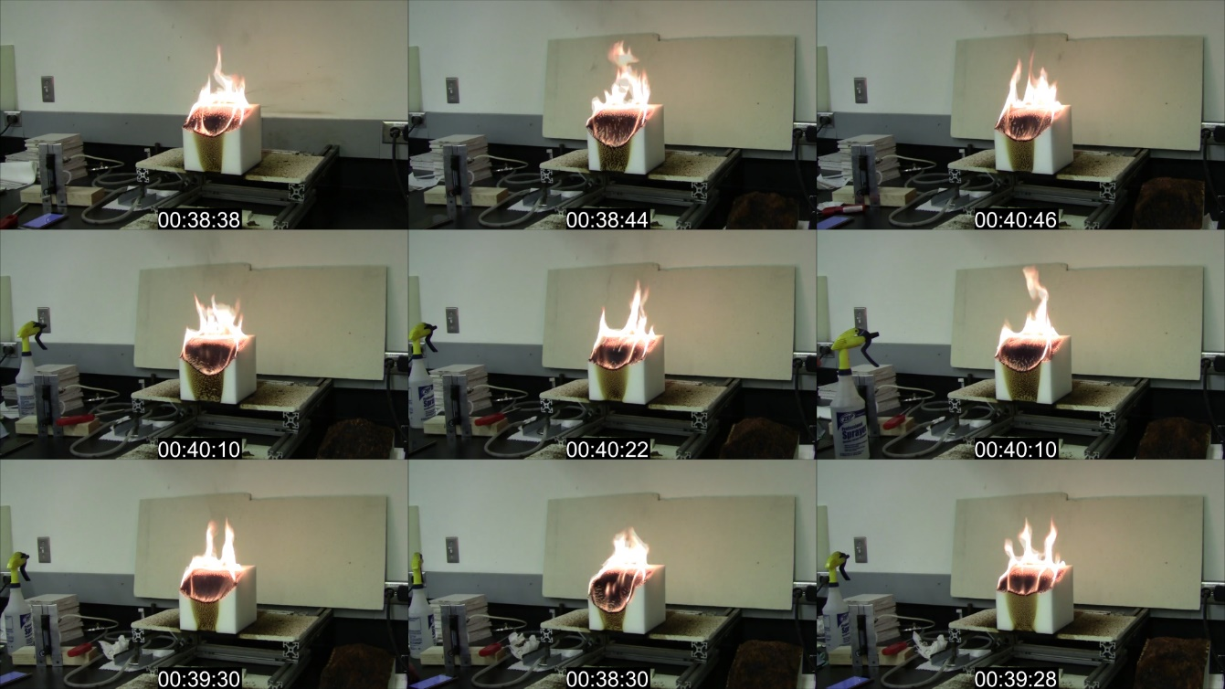
Figure 5B - The fire burns down the face and across the top.
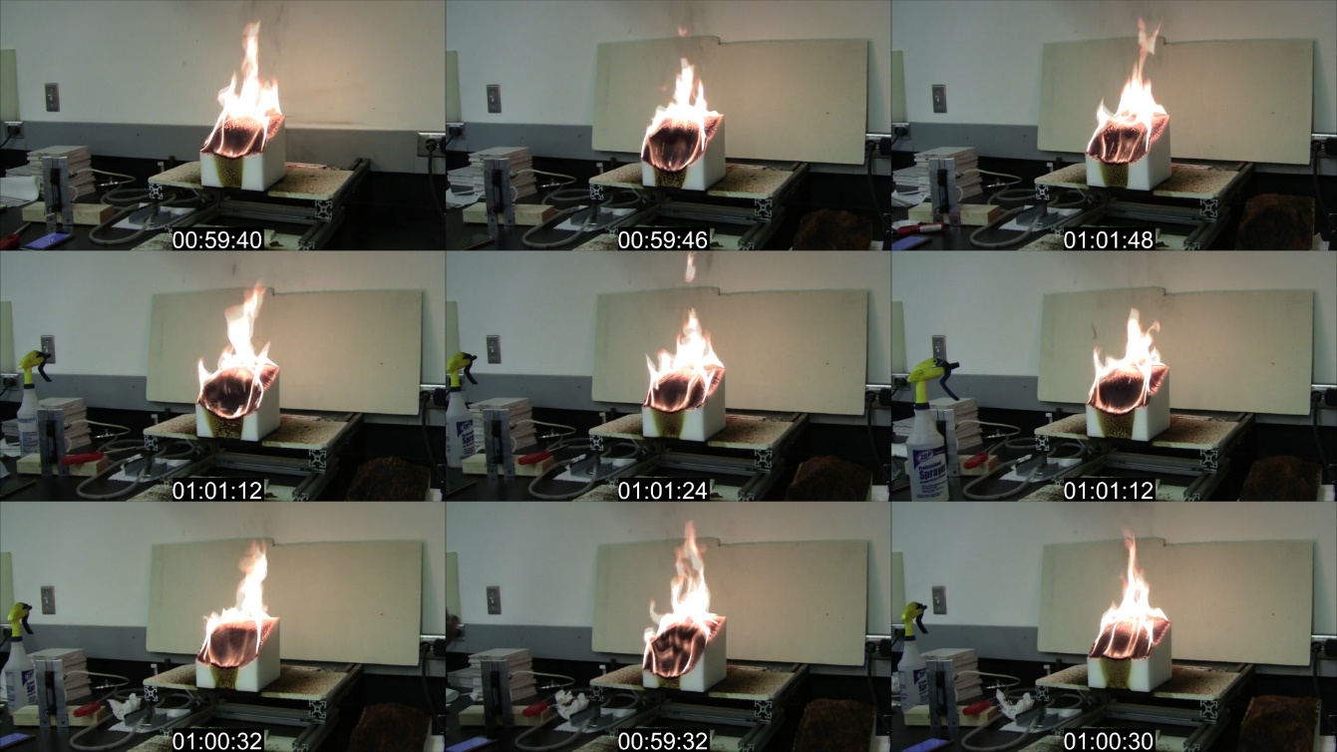
Figure 6B - The fire burns into the cube more.

Figure 7B - After the cubes were extinguished. The cubes are in order from T1 on the left to T9 on the right.

Appendix C – Additional Heat Release Rate Data

$$HRR={\left[\frac{(H+1.02*D)}{0.23}\right]}^{2.5}$$
H = Flame Height (m)
HRR = Heat Release Rate (kW)
D = Hydraulic Diameter (m)

Using the above equation, we got the HRR data shown below which includes the data reported above in the report. The flame height was taken from the videos of the tests in 20 second averages. In addition to this we also calculated the HRR without using the hydraulic diameter, D. These two calculations give us a range of HRRs for each test. When the hydraulic diameter is used the HRR is greater. This is only true for the pit tests. When calculating HRR with both equations for the corner tests the curves were almost identical.

HRR of Corner Tests

Figure 1C - System 1 Bottom Ignition

Figure 2C - System 2 Bottom Ignition

Figure 3C - System 2 Top Ignition

Figure 4C - System 3 Bottom Ignition

Figure 5C - System 3 Top Ignition

HRR of Pit Tests

Figure 6C - System 1 using Diameter

Figure 7C - System 1 without using Diameter

Figure 8C - System 2 using Diameter

Figure 9C - System 2 without using Diameter

Figure 10C - System 3 using Diameter

Figure 11C - System 3 without using Diameter

Carignan, C. C., Fang, M., Stapleton, H. M., Heiger-Bernays, W., McClean, M. D., & Webster, T. F. (2016). Urinary biomarkers of flame retardant exposure among collegiate U.S. gymnasts. Environment International, 94, 362-368. doi:10.1016/j.envint.2016.06.030
Courtney C. Carignan, Wendy Heiger-Bernays, Michael D. McClean, Simon C. Roberts, Heather M. Stapleton, Andreas Sjödin, and Thomas F. Webster. (2013). Flame retardant exposure among collegiate united states gymnasts. (). doi:10.1021/es4037868
TECHNICAL BULLETIN 117, State of California department of consumer affairs bureau of home furnishings and thermal insulation 3485 orange grove avenue north highlands, ca 95660-5595
Standard test methods for cigarette ignition resistance of components of upholstered furniture doi:10.1520/E1353-08A
SRM 1196 - standard cigarette for ignition resistance testing &nbsp; Retrieved from https://www-s.nist.gov/srmors/view_detail.cfm?srm=1196
Drysdale, D. (1985). An introduction to fire dynamics. Chichester u.a: Wiley.

